# Car Price Prediction - Regression

Objectives

The primary goal of this project is to develop a robust regression model to predict used car prices for a reseller based on various listed features and specifications. In addition to predicting prices, the project focuses on identifying feature importance and mitigating overfitting through the application of regularization techniques.

There can be several business objectives for this, such as:

* **Price Prediction**: Model car prices based on features like mileage, fuel type, and performance.
* **Market Analysis**: Explore trends and preferences in the used car market.
* **Feature Importance**: Identify the most important factors influencing car prices

Data Dictionary

|  |  |
| --- | --- |
| Variable | Description |
| make_model | The brand and model of the vehicle (e.g., 'Audi A1'). |
| body_type | The body style of the vehicle, such as Sedan, Compact, or Station Wagon. |
| price | The listed price of the car in currency. |
| vat | Indicates the VAT status for the vehicle's price (e.g., VAT deductible, Price negotiable). |
| km | The total mileage (in kilometers) of the vehicle, indicating its usage. |
| Type | Condition of the vehicle, whether it's 'Used' or 'New'. |
| Fuel | Type of fuel the vehicle uses, such as 'Diesel', 'Benzine', etc. |
| Gears | The number of gears in the vehicle's transmission. |
| Comfort_Convenience | Comfort and convenience features, such as 'Air conditioning', 'Leather steering wheel', 'Cruise control', and more. |
| Entertainment_Media | Media features available in the vehicle, including 'Bluetooth', 'MP3', 'Radio', etc. |
| Extras | Additional features like 'Alloy wheels', 'Sport suspension', etc. |
| Safety_Security | Safety features like 'ABS', 'Airbags', 'Electronic stability control', 'Isofix', etc. |
| age | Age of the car (calculated based on the model year). |
| Previous_Owners | The number of previous owners the car has had. |
| hp_kW | Engine power in kilowatts (kW), indicating the performance capacity of the engine. |
| Inspection_new | Indicates whether the car has recently undergone an inspection (1 for yes, 0 for no). |
| Paint_Type | The type of paint on the car, such as 'Metallic', 'Matte', etc. |
| Upholstery_type | The material used for the interior upholstery, such as 'Cloth', 'Leather', etc. |
| Gearing_Type | The type of transmission the car uses, either 'Automatic' or 'Manual'. |
| Displacement_cc | The engine displacement in cubic centimeters (cc), indicating the size of the engine. |
| Weight_kg | The total weight of the vehicle in kilograms. |
| Drive_chain | The type of drivetrain, indicating whether it's 'Front' or 'Rear' wheel drive. |
| cons_comb | The combined fuel consumption in liters per 100 kilometers. |

## Data Loading

* Define local and AWS environment configuration variables for base directory, raw data, processed data, models; for easy porting from local to AWS environment
* Import necessary libraries from pandas, numpy, mapplotlin, seaborn, sklearn, statsmodels, IPython, collections and warnings

### Load the Dataset

* df_raw 🡨 Read the Car_Price.csv file
* Assess the dataset information, columns, data types, row counts

<class 'pandas.core.frame.DataFrame'>

RangeIndex: 15915 entries, 0 to 15914

Data columns (total 23 columns)

# Analysis and Feature Engineering

## Preliminary Analysis and Frequency Distributions

### Handle Missing Values

#### Standardize & Classify Columns, Define Imputation Strategy

* Standardize column names by converting to lowercase and replacing spaces with underscores
* Categorize the columns into
  + Category columns
  + Numeric columns
    - Numeric columns with imputation with mean
    - Numeric columns with imputation with median
    - Numeric columns with imputation with mode
  + Target column
  + Feature columns
* Use below Imputation Strategy
  + Categorical Columns Imputation Strategy - Use mode for all
  + Numeric Columns Imputation Strategy
    - If target column has missing values, better to drop the rows as imputing target variable can lead to bias
    - For other columns, follow below strategy:

|  |  |  |
| --- | --- | --- |
| Categorical Features | Suggested Imputation | Rationale |
| 'make_model', 'body_type', 'vat', 'type', 'fuel', 'comfort_convenience', 'entertainment_media', 'extras', 'safety_security', 'paint_type', 'upholstery_type', 'gearing_type', 'drive_chain' | Mode | Discrete few values |
|  |  |  |

|  |  |  |
| --- | --- | --- |
| Numeric Features | Suggested Imputation | Rationale |
| km | Median | Mileage is usually skewed, median more robust than mean |
| Gears | Mode | Discrete small integers, categorical-like |
| age | Median | Skewed distribution possible, median more robust |
| Inspection_new | Mode | Binary categorical (0/1) |
| Previous_Owners | Mode | Small integers, categorical-like |
| hp_kW | Mean or Median | Continuous; use mean if symmetric, median if skewed |
| Displacement_cc | Mean | Continuous, usually symmetric within ranges |
| Weight_kg | Mean | Continuous, symmetric, less outlier-prone |
| cons_comb | Mean | Fuel consumption continuous, usually close to normal distribution |

|  |  |  |
| --- | --- | --- |
| Target | Suggested Imputation | Rationale |
| price | Median | Target variable; drop if only few missing records, but if you need imputation and it is a skewed distribution, median is safer than mean |

#### Fix Missing Values – Drop vs Impute

* Create a dataset with list of columns and their missing value proportions
* If target column has missing values, better to drop the rows as imputing target variable can lead to bias
* For all other columns, analyze missing value proportions and identify the action with below approach:
  + Missing % = 0%, no action needed
  + Missing % between 0-5%, drop the column
  + Missing % between 5-30%, impute using approach designed in 2.1.1
  + Missing % > 30%, Check data source, likely drop column

**Results:**

|  |  |  |  |  |  |
| --- | --- | --- | --- | --- | --- |
| Column Name | Data Type | Missing Count | Missing % | Impute Type | Action |
| make_model | object | 0 | 0.0 | mode | none |
| age | float64 | 0 | 0.0 | median | none |
| drive_chain | object | 0 | 0.0 | mode | none |
| weight_kg | float64 | 0 | 0.0 | mean | none |
| displacement_cc | float64 | 0 | 0.0 | mean | none |
| gearing_type | object | 0 | 0.0 | mode | none |
| upholstery_type | object | 0 | 0.0 | mode | none |
| paint_type | object | 0 | 0.0 | mode | none |
| inspection_new | int64 | 0 | 0.0 | mode | none |
| hp_kw | float64 | 0 | 0.0 | mean | none |
| previous_owners | float64 | 0 | 0.0 | mode | none |
| safety_security | object | 0 | 0.0 | mode | none |
| body_type | object | 0 | 0.0 | mode | none |
| extras | object | 0 | 0.0 | mode | none |
| entertainment_media | object | 0 | 0.0 | mode | none |
| comfort_convenience | object | 0 | 0.0 | mode | none |
| gears | float64 | 0 | 0.0 | mode | none |
| fuel | object | 0 | 0.0 | mode | none |
| type | object | 0 | 0.0 | mode | none |
| km | float64 | 0 | 0.0 | median | none |
| vat | object | 0 | 0.0 | mode | none |
| price | int64 | 0 | 0.0 | drop | none |
| cons_comb | float64 | 0 | 0.0 | mean | none |

### Identify Numerical Predictors and Plot Frequency Distribution

* Create 2 histogram plots per numeric column
  + First plot using regular yscale
  + Second plot using yscale = ‘log’
* Plot box plot and violin plot for the numeric columns

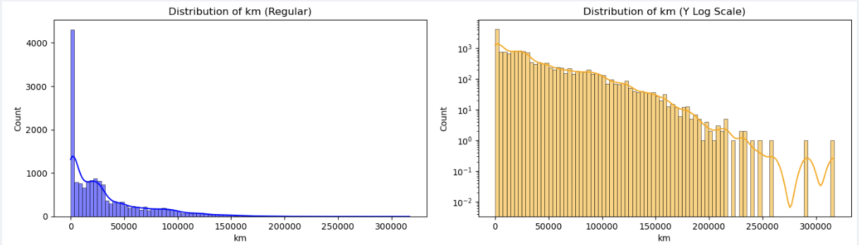

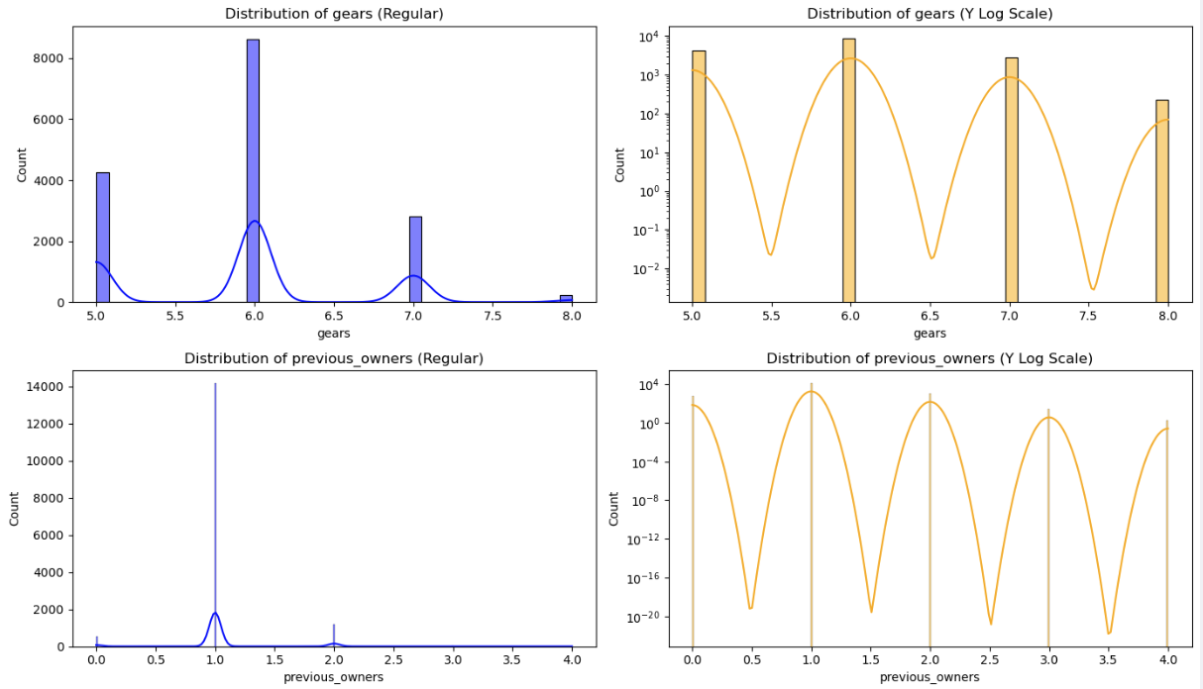

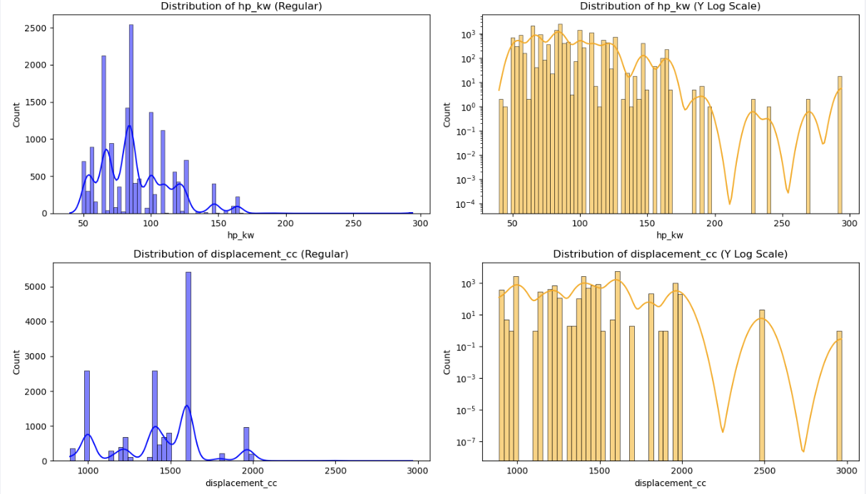

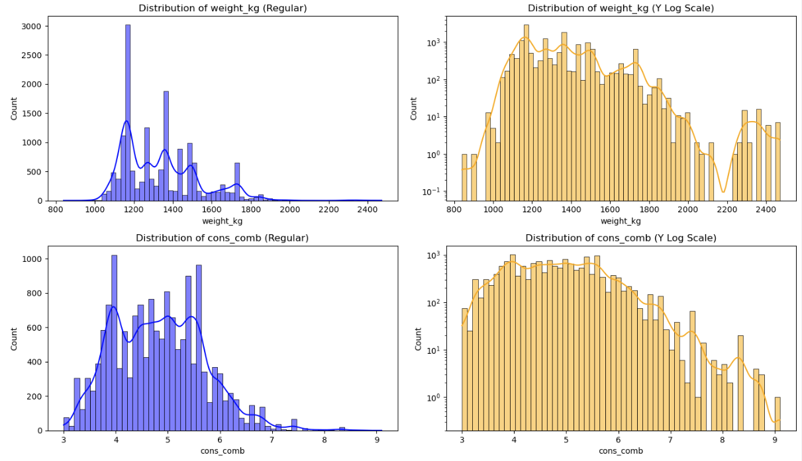

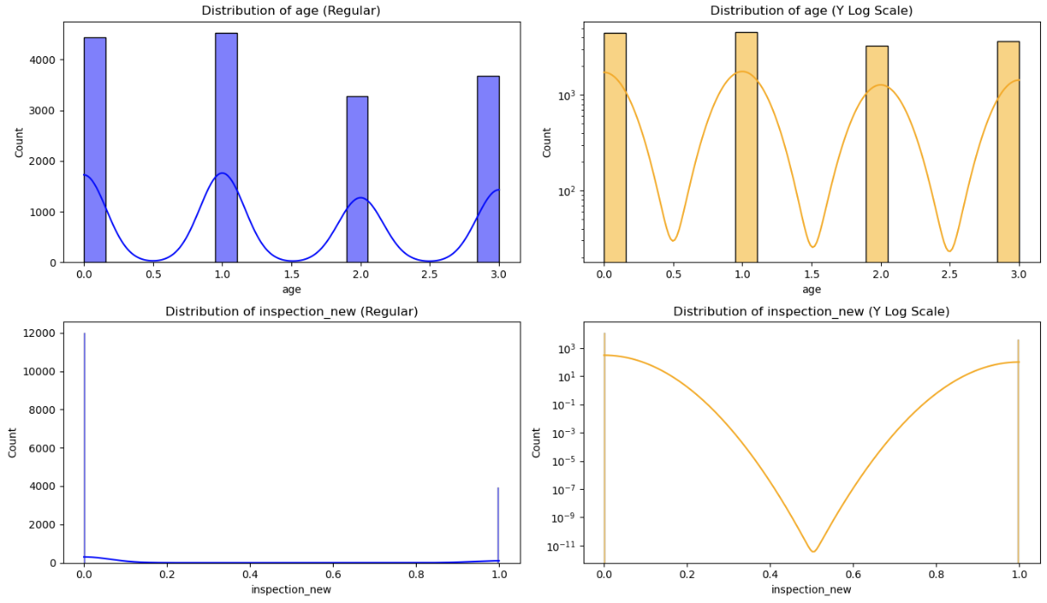

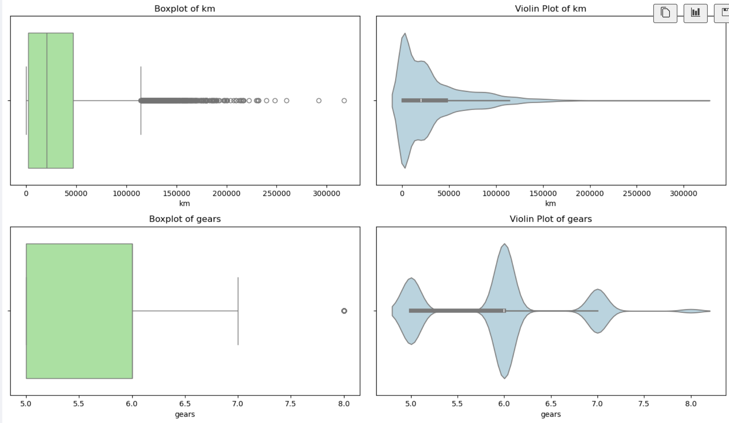

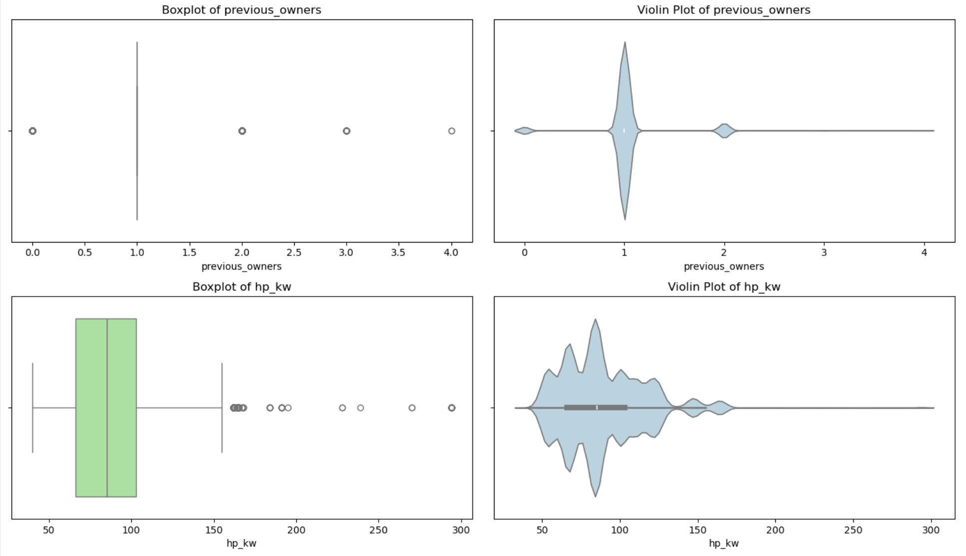

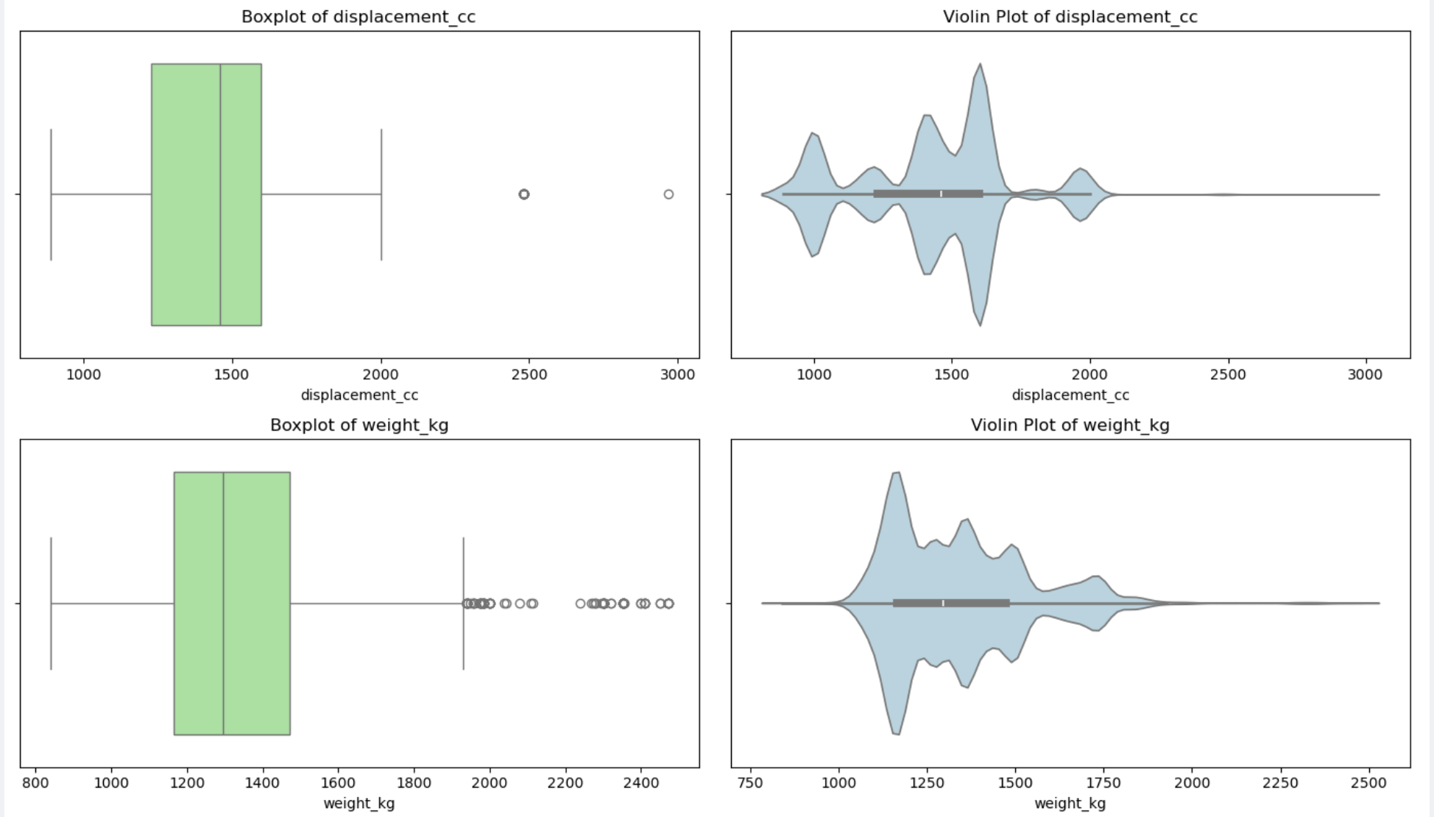

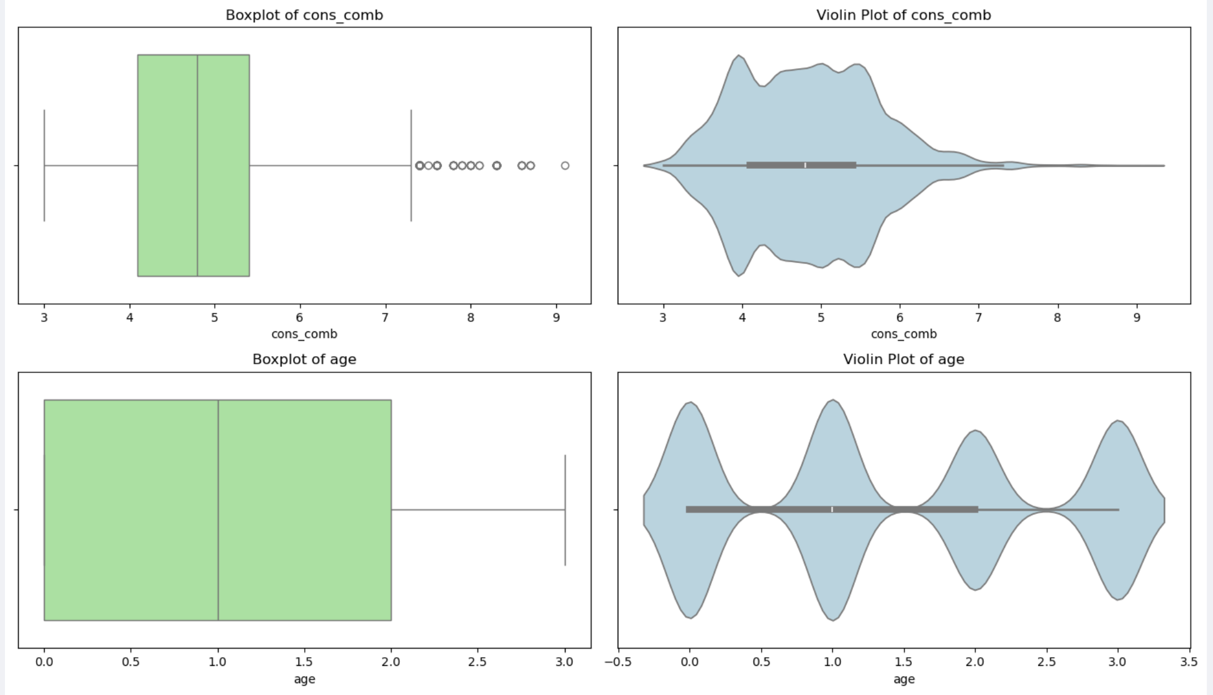

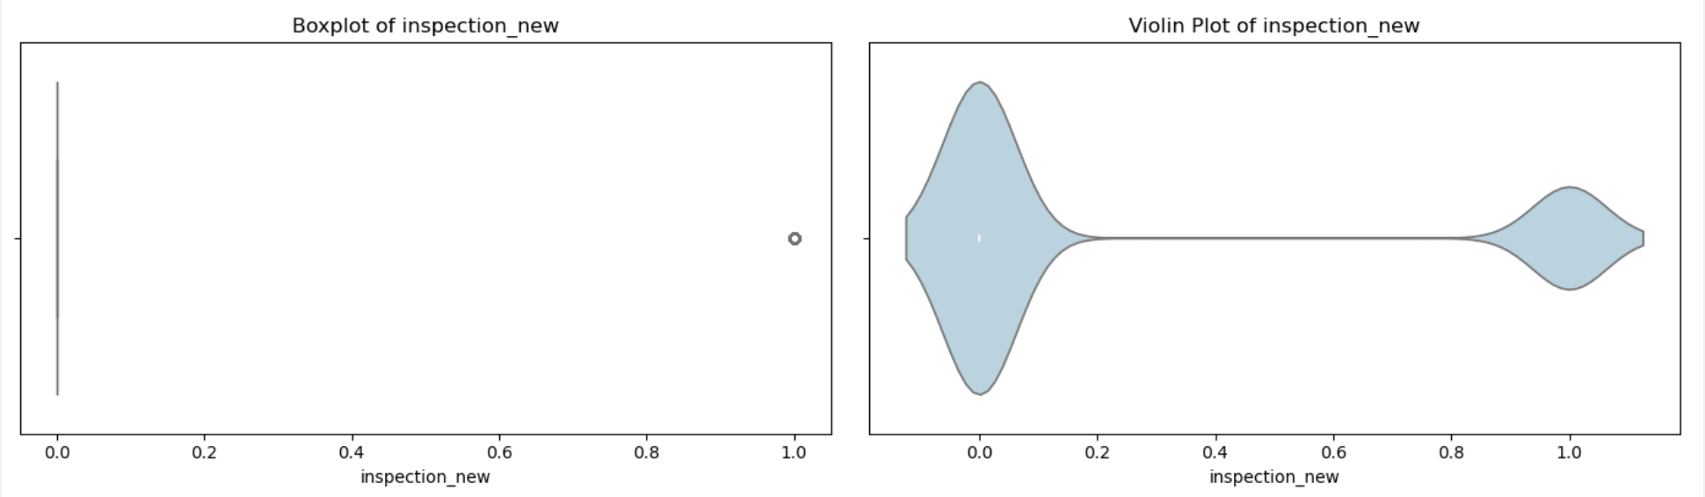

### Idendity Categorical Predictors and Plot Frequency Distributions

* Plot bar chart for each categorical column, with counts on x-axis & top-10 categories on the y-axis

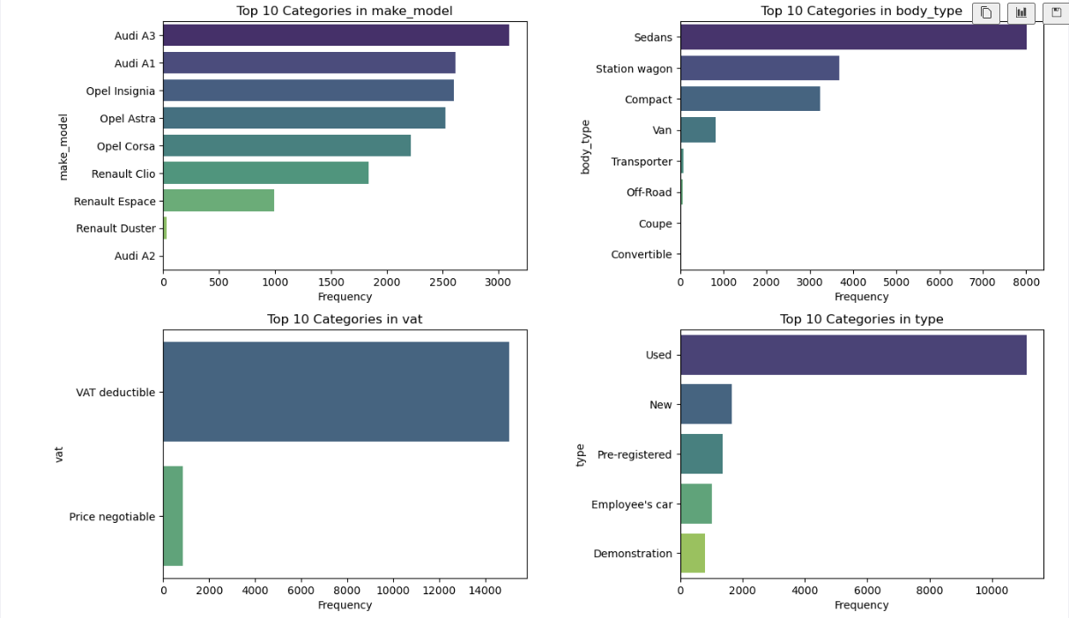

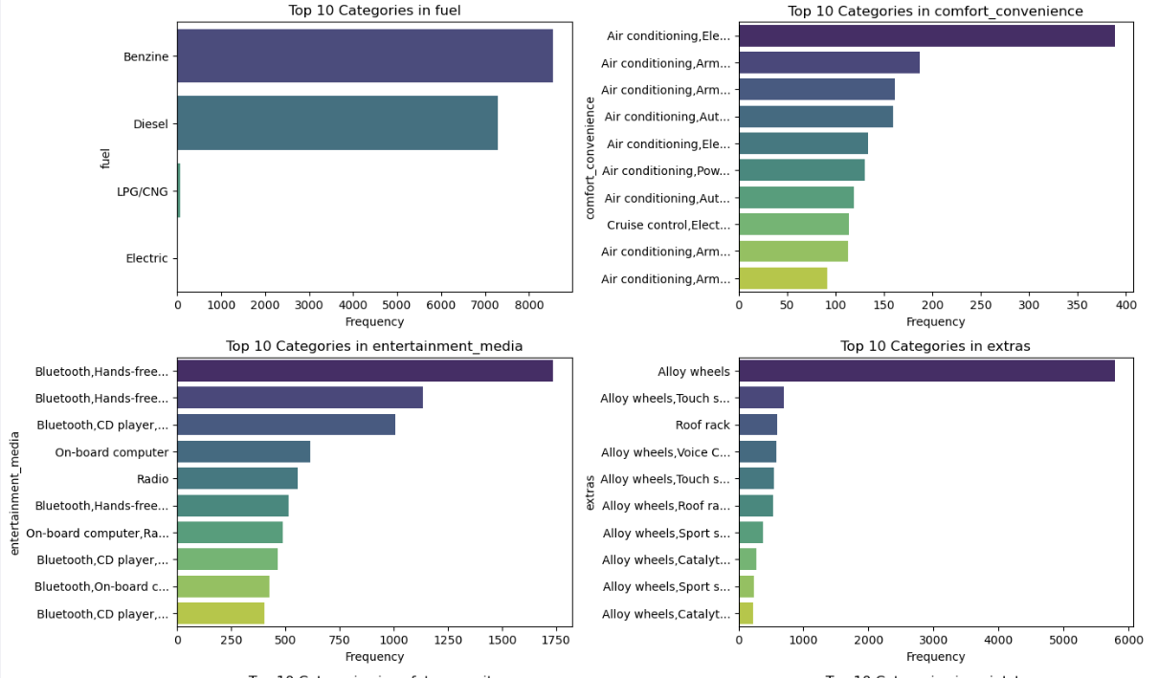

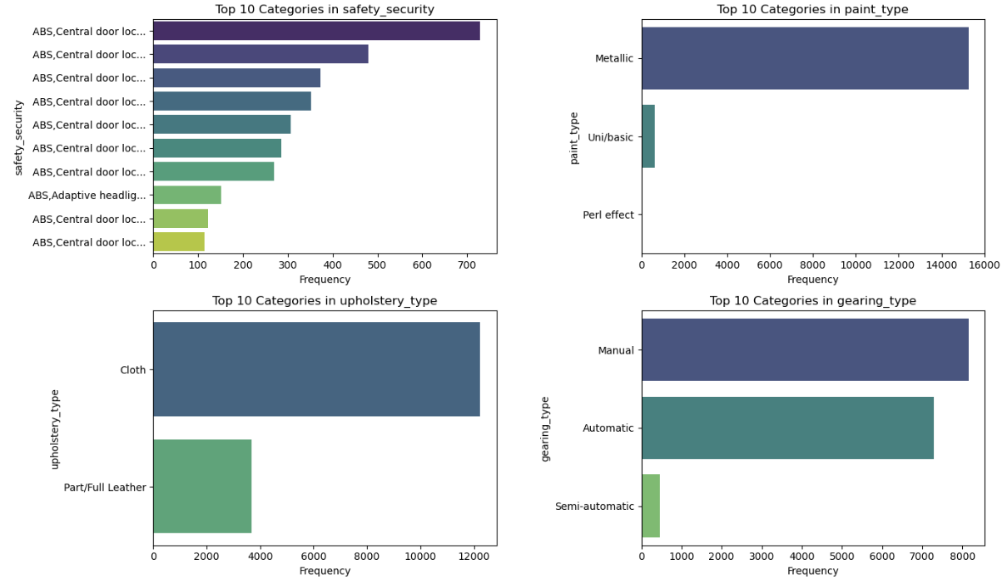

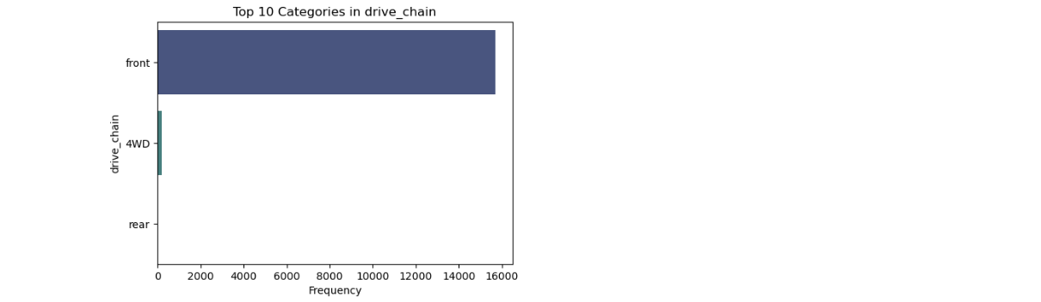

* Note: The columns `["Comfort_Convenience", "Entertainment_Media", "Extras", "Safety_Security"]` are all categorical columns with multiple discrete values in comma separated format in each cell. These will be treated with multi-label hot encoding later.

### Fix Columns with Low Frequency Values & Class Imbalances

* Strategy for ‘type’ column
  + Combine pre-registered and new cars into one
  + Combine employee car and demo car into one 🡪 low mileage/ low usage
* Strategy for all other categorical columns
  + Determine frequency % for each label value using value_counts
  + If frequency > 5% for all labels, no change needed
  + If frequency <=5% for only 1 label, no change needed
  + If frequency <=5% for more than 1 labels, => combine low frequency values in the column into ‘Other’ label

---------------------------------------------------------------------------

Value counts for column 'type':

type

Used 0.697141

New 0.103613

Pre-registered 0.085705

Employee's car 0.063525

Demonstration 0.050016

Name: proportion, dtype: float64

Strategy for low frequency values in column 'type':

- Pre-registered → similar to New cars (low mileage, low usage) → combine with New

- Employee's car + Demonstration → short-term usage, small mileage → combine into Short-use

Post Processing:

---------------------------------------------------------------------------

Value counts for column 'type':

type

Used 0.697141

New 0.189318

Short-use 0.113541

Name: proportion, dtype: float64

---------------------------------------------------------------------------

Value counts for column 'body_type':

body_type

Sedans 0.502922

Station wagon 0.231040

Compact 0.203582

Van 0.051335

Transporter 0.005529

Off-Road 0.003519

Coupe 0.001571

Convertible 0.000503

Name: proportion, dtype: float64

Combining low frequency categories in 'body_type' into 'Other'

Post-Processed Value counts for column 'body_type':

body_type

Sedans 0.502922

Station wagon 0.231040

Compact 0.203582

Van 0.051335

Other 0.011122

Name: proportion, dtype: float64

---------------------------------------------------------------------------

Value counts for column 'vat':

vat

VAT deductible 0.945272

Price negotiable 0.054728

Name: proportion, dtype: float64

No change needed as all values are significant in 'vat' with >5% frequency

---------------------------------------------------------------------------

Value counts for column 'fuel':

fuel

Benzine 0.537103

Diesel 0.458561

LPG/CNG 0.004021

Electric 0.000314

Name: proportion, dtype: float64

Combining low frequency categories in 'fuel' into 'Other'

Post-Processed Value counts for column 'fuel':

fuel

Benzine 0.537103

Diesel 0.458561

Other 0.004336

Name: proportion, dtype: float64

---------------------------------------------------------------------------

Value counts for column 'paint_type':

paint_type

Metallic 0.957964

Uni/basic 0.040025

Perl effect 0.002011

Name: proportion, dtype: float64

Combining low frequency categories in 'paint_type' into 'Other'

Post-Processed Value counts for column 'paint_type':

paint_type

Metallic 0.957964

Other 0.042036

Name: proportion, dtype: float64

---------------------------------------------------------------------------

Value counts for column 'upholstery_type':

upholstery_type

Cloth 0.768709

Part/Full Leather 0.231291

Name: proportion, dtype: float64

No change needed as all values are significant in 'upholstery_type' with >5% frequency

---------------------------------------------------------------------------

Value counts for column 'gearing_type':

gearing_type

Manual 0.512033

Automatic 0.458498

Semi-automatic 0.029469

Name: proportion, dtype: float64

No change needed as only one low frequency value in 'gearing_type' with <=5% frequency

---------------------------------------------------------------------------

Value counts for column 'drive_chain':

drive_chain

front 0.986931

4WD 0.012818

rear 0.000251

Name: proportion, dtype: float64

Combining low frequency categories in 'drive_chain' into 'Other'

Post-Processed Value counts for column 'drive_chain':

drive_chain

front 0.986931

Other 0.013069

Name: proportion, dtype: float64

### Identify Target Variable and Plot Frequency Distributions

* Plot histogram on ‘Price’ using normal and log y-scale
* Plot box plot and violin plot on ‘Price’
* If target variable is skewed, perform suitable transformation
  + Check original skewness
  + Check there are no negative or zero values
  + Apply lop1p transformation on Y
  + Check skewness after applying log transformation
  + If absolute value of post-transformation skew
    - <0.5 – fairly symmetric
    - 0.5 to 1 – moderately skewed
    - >1 – highly skewed
* Plot histogram, box plot, violin plot on ‘price’ post outlier treatment

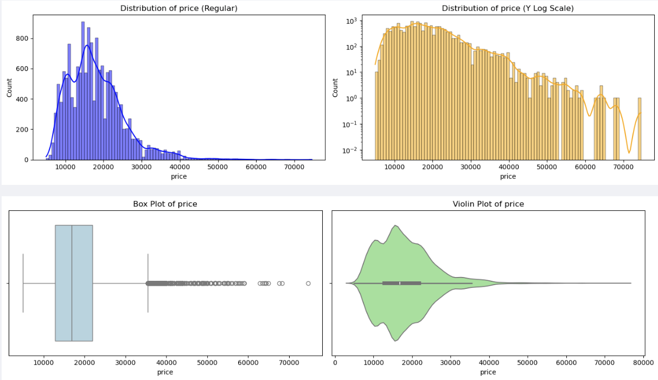

Applying log transformation to target column 'price' to reduce skewness.

Original skewness of 'price': 1.236169412899669

negatives: 0, zeros: 0

After log1p: skew=-0.031

Log transformation output : fairly symmetric (|skew| < 0.5)

|  |  |  |  |
| --- | --- | --- | --- |
| Skewness value | Interpretation | Visual shape | Meaning for regression |
| 0 | Perfectly symmetric | Bell-shaped | Ideal for linear regression (normal residuals). |
| > 0 (positive skew) | Right tail longer (many small values, few large ones) | Right-heavy | Common for prices, incomes, sales — most are small, few are huge. |
| < 0 (negative skew) | Left tail longer (many large values, few small ones) | Left-heavy | Rare in price data; usually means a floor effect. |

Check few outlier values for high end cars

Mean price for Audi A3: 20996.693251533743

Mean price for Renault Espace: 30080.21190716448

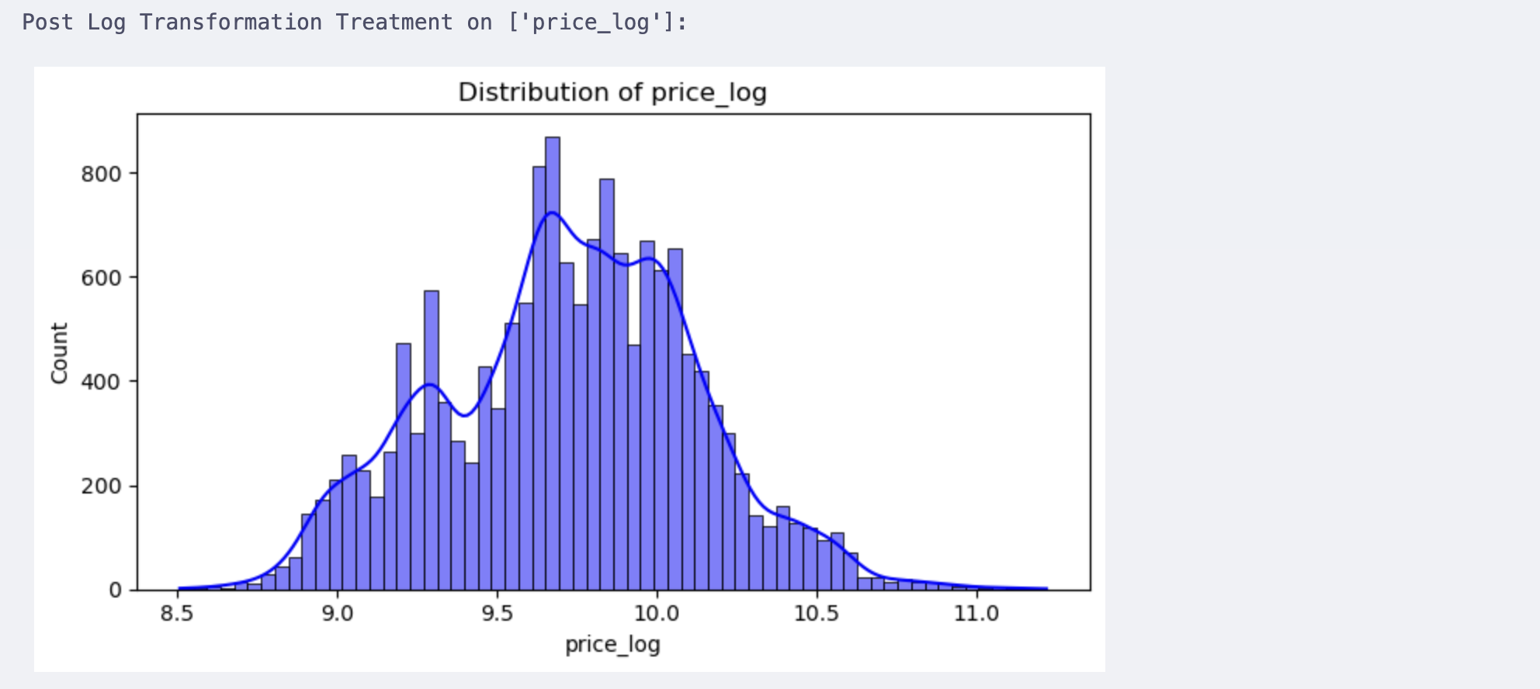

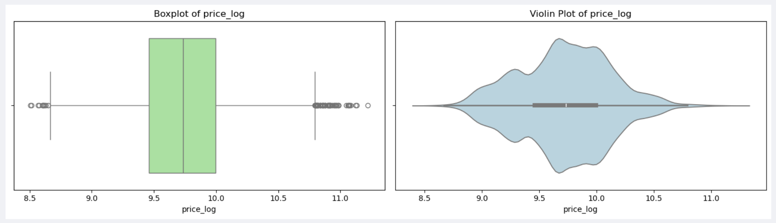

## Correlation Analysis

Use the transformed target (price_log) for correlation analysis

**Why**:

* We’re building your model on the transformed target, so all pre-model analyses (correlation, feature selection, etc.) should reflect relationships with that version of the target.
* **Log transformation linearizes nonlinear relationships**.
  + Many numerical predictors (like hp_kw, km, age) have multiplicative or exponential effects on price.
  + Taking log(price) converts those into roughly additive linear relationships — exactly what correlation (and linear regression) assume.
* **Pearson correlation assumes linearity and roughly normal variables.**
  + The original price was right-skewed (skew ≈ +1.24), violating this assumption.
  + price_log (skew ≈ 0) satisfies it much better, making correlations meaningful and less dominated by a few luxury-car outliers.
* **Mutual information for categorical features**: is nonparametric and scale-invariant, so it’s fine either way — but to keep consistency, use the same target (price_log) everywhere.

### Correlation Map Between Features and Target Variable

* Separate features and target into X and y
* Find correlation of numeric columns with target variable ‘price_log’
* Create a data frame with feature name, data type, abs(score), sign
* Plot a heatmap of numeric features correlation
* Display the numeric features with positive or negative high correlation with ‘price’

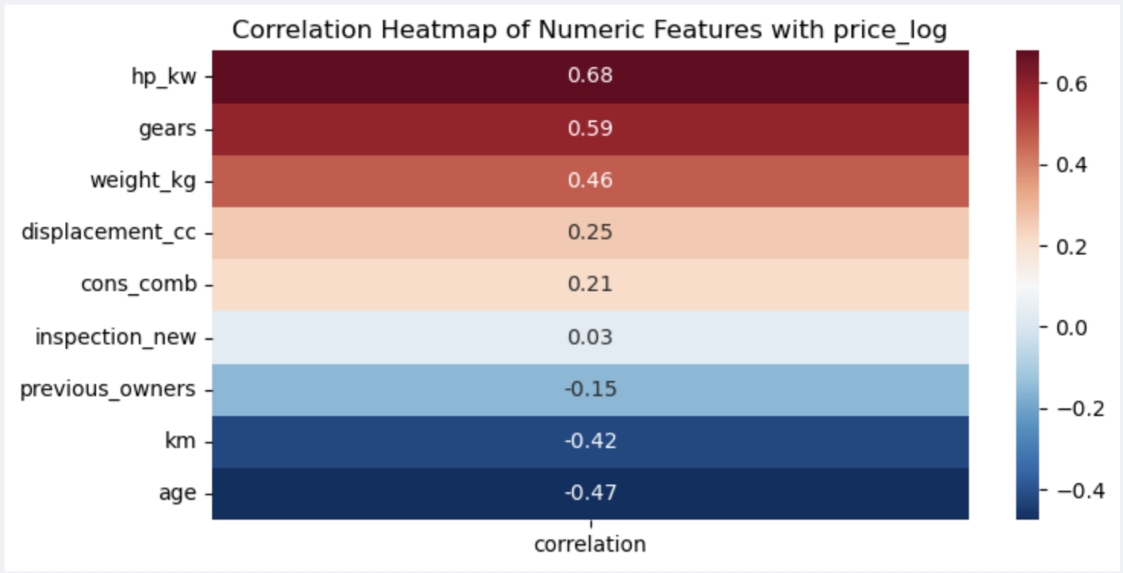

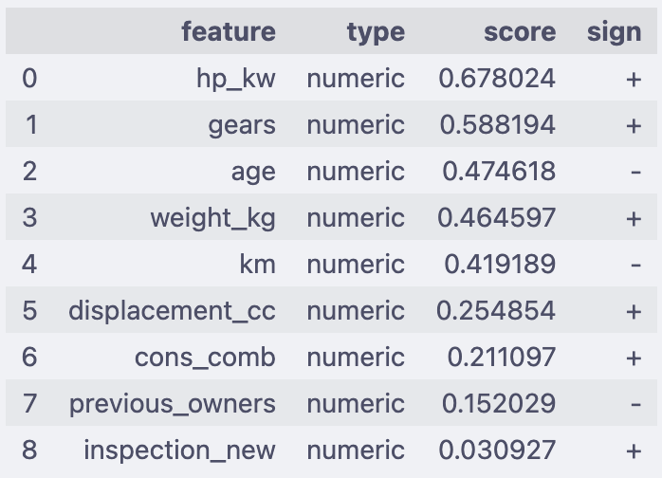

### Analyze Correlation Between Categorical Variable and Target Variable

* Separate features and target variables into X and y
* Select the list of categorical variables, excluding the ones that need multi-label hot encoding
* Make a copy of the data frame
* Apply one-hot encoding on the selected category variables
* Calculate Mutual Information (MI) scores of the category variables with target column price_log
* Append results into data frame with columns : feature, type = ‘categorical’, score, sign = ‘none’
* Plot bar chart with feature on x-axis and score on y-axis, for Top-k features based on score
* Plot bar chart with feature on x-axis and score on y-axis, for Bottom-k features based on score

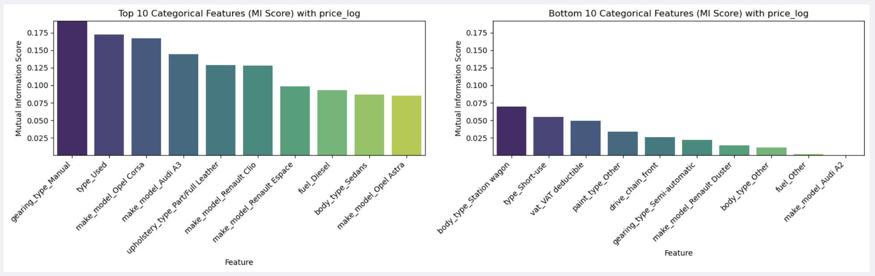

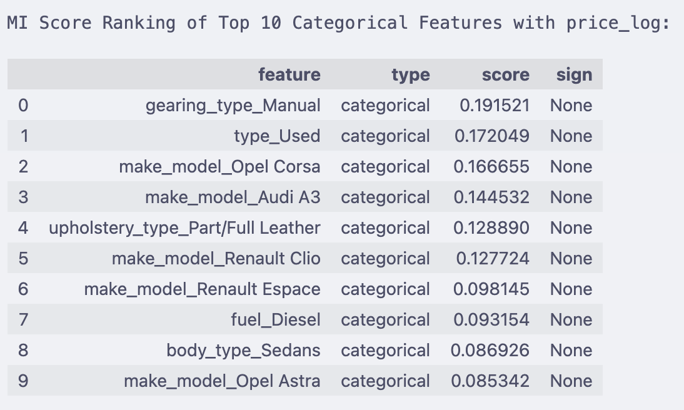

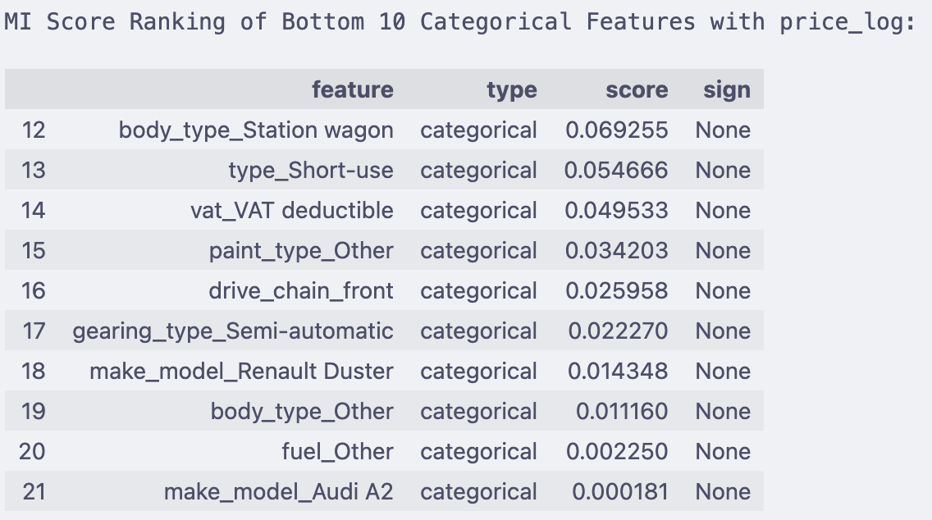

Combine the numeric and categorical features, and display the top-20 features with high correlation to target ‘price_log’.

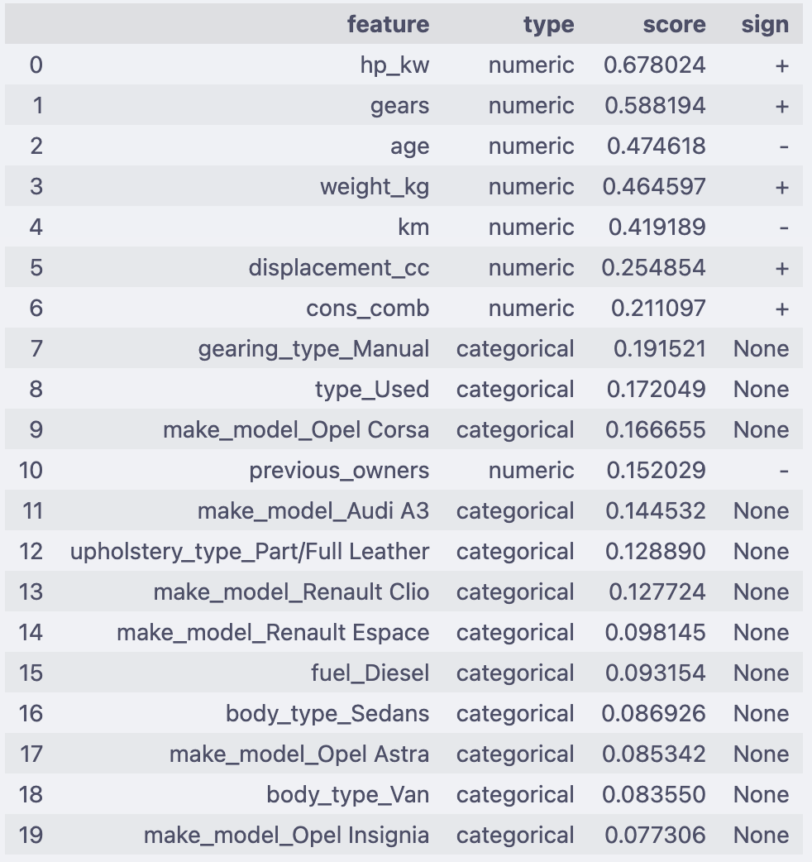

#### Feature Importance Summary

The table below combines the top numerical and categorical features most strongly associated with the target variable.

* **Numerical features** are ranked by absolute Pearson correlation with the target.
* **Categorical features** are ranked by mutual information (MI) with the target.
* This combined ranking helps prioritize which features to focus on for modeling and interpretation.

|  |  |  |  |  |  |
| --- | --- | --- | --- | --- | --- |
| Rank | Feature | Type | Score | Sign | Inference |
| 1 | hp_kw | Numeric | 0.668 | + | Strongest driver of price. More engine power → higher price. |
| 2 | gears | Numeric | 0.558 | + | More gears (modern transmissions) → generally higher prices. |
| 3 | age | Numeric | 0.475 | – | Older cars lose value. Strong negative effect. |
| 4 | weight_kg | Numeric | 0.465 | + | Heavier cars (luxury/SUVs) are costlier. |
| 5 | km | Numeric | 0.419 | – | Higher mileage reduces price, though less than age. |
| 6 | displacement_cc | Numeric | 0.225 | + | Bigger engines → higher prices, though weaker than horsepower. |
| 7 | cons_comb | Numeric | 0.211 | + | Higher consumption → often premium/performance cars. |
| 8 | gearing_type_Manual | Categorical | 0.192 | – | Manual cars usually cheaper than automatics (signal of lower price). |
| 9 | type_Used | Categorical | 0.172 | – | Used cars priced lower than new ones. |
| 10 | make_model_Opel Corsa | Categorical | 0.167 | – | Budget model → pulls price down. |
| 11 | make_model_Audi A3 | Categorical | 0.145 | + | Premium model → lifts price. |
| 12 | previous_owners | Numeric | 0.152 | – | More owners reduce resale value. |
| 13 | make_model_Renault Clio | Categorical | 0.129 | – | Mass-market model, generally lower priced. |
| 14 | upholstery_type_Part/Full Leather | Categorical | 0.119 | + | Premium interiors increase price. |
| 15 | make_model_Renault Espace | Categorical | 0.098 | – | Family van, not premium → lower prices. |
| 16 | fuel_Diesel | Categorical | 0.093 | ± | Diesel cars affect price; historically valuable in EU, now mixed. |
| 17 | body_type_Sedans | Categorical | 0.087 | ± | Sedans have moderate premium depending on market. |
| 18 | make_model_Opel Astra | Categorical | 0.085 | – | Mid-segment Opel → relatively lower priced. |
| 19 | make_model_Opel Insignia | Categorical | 0.077 | – | Slightly higher than Astra but still budget vs luxury brands. |
| 20 | body_type_Van | Categorical | 0.084 | – | Vans typically lower resale vs SUVs/sedans. |

#### Pair Plot for Correlation Analysis

* Create a pair plot across all numerical columns and analyze data

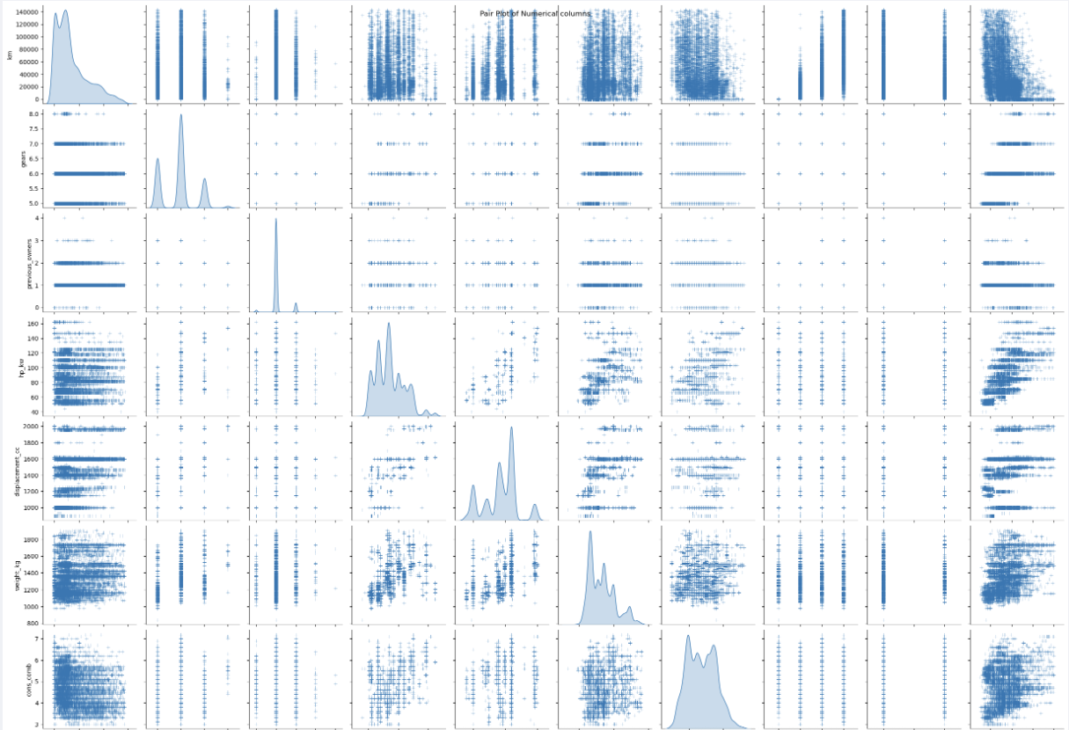

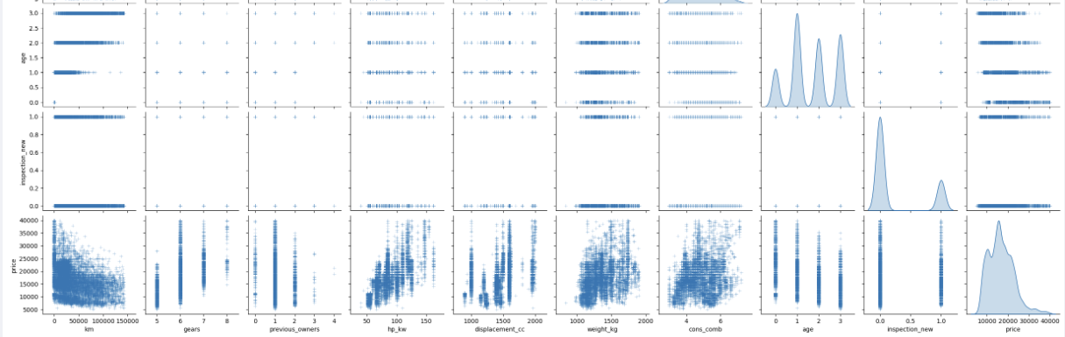

The pair plot confirms the correlations as identified earlier between numeric categorical variables and target ‘price_log’.

## Outlier Analysis

* Identify outliers in the numeric categorical variables
* Plot histogram with regular and log y-scale
* Plot box plot and violin plot

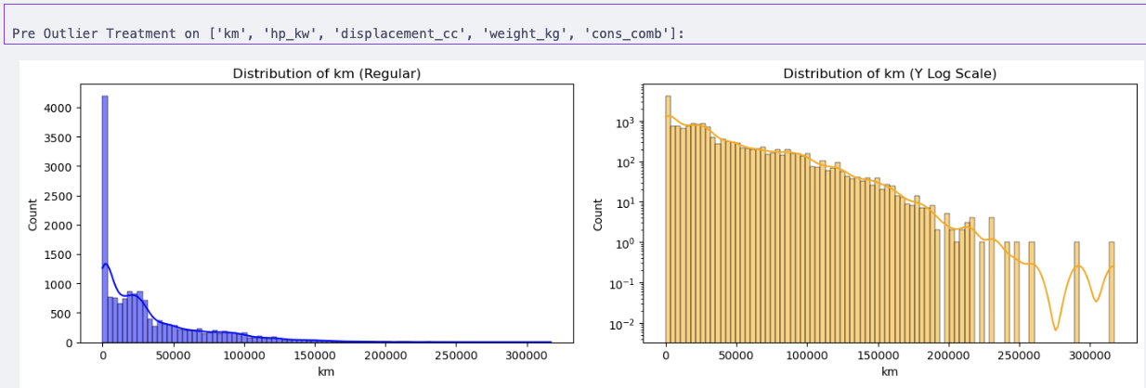

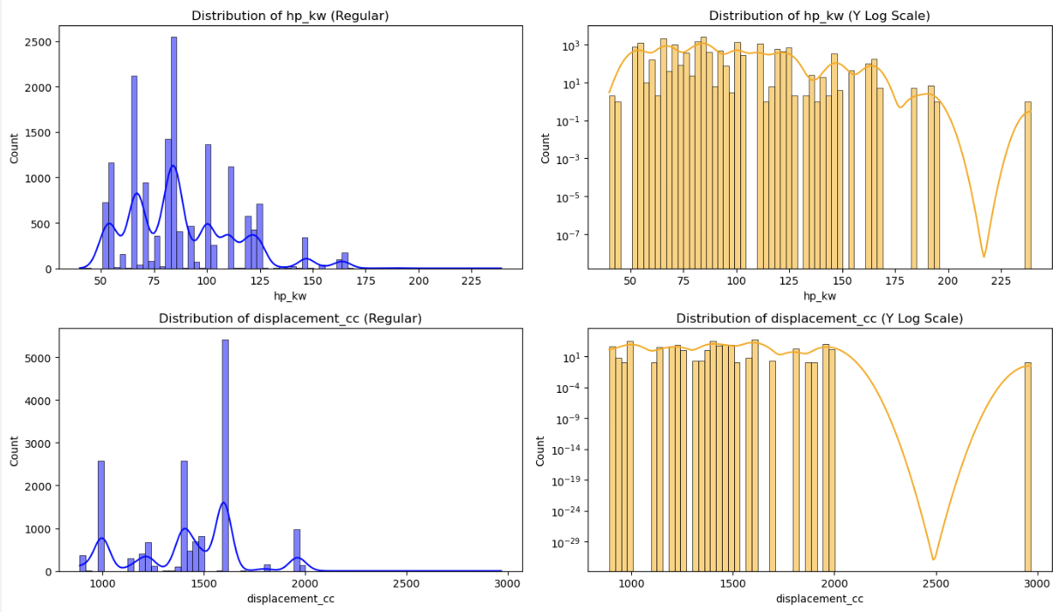

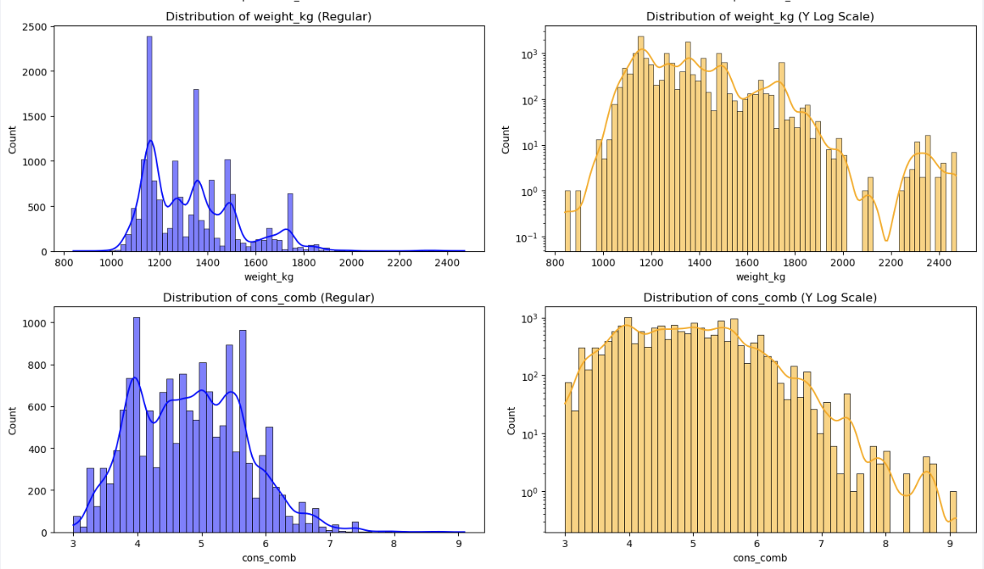

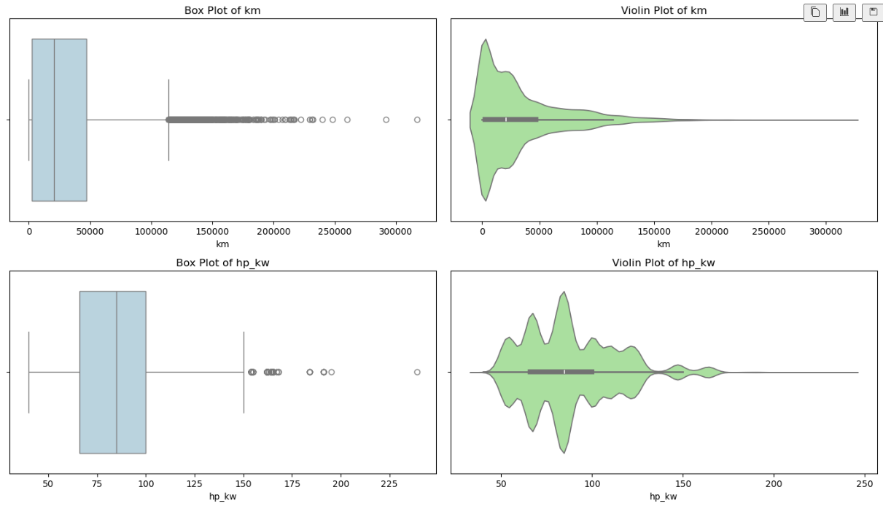

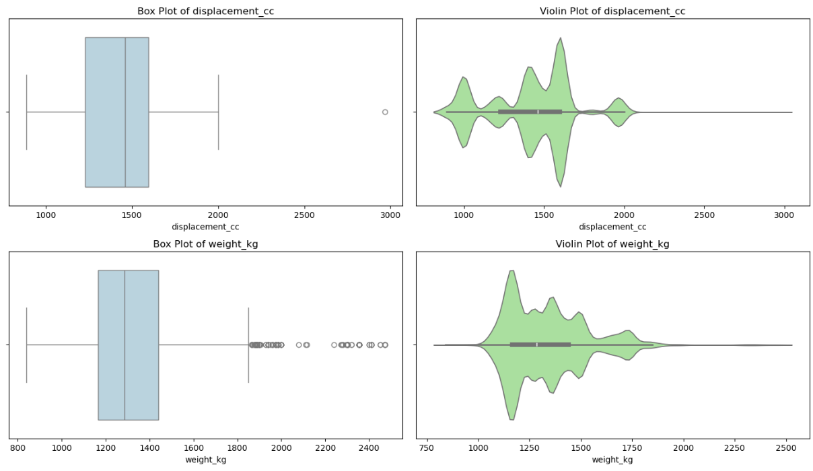

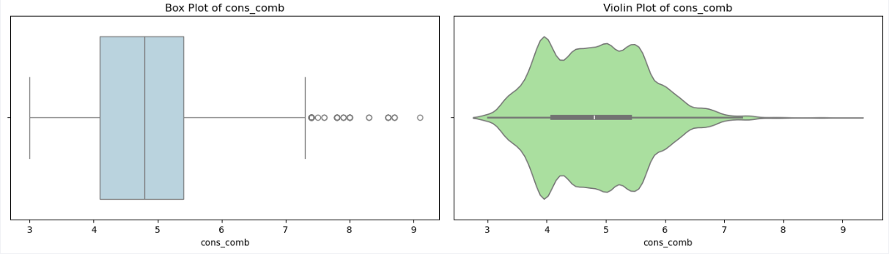

### Handle Outliers in Numeric Categorical Variables

* Use z-score functioned defined earlier to identify outliers using threshold between 2 and 3
* Remove outliers, which are beyond 3 sigma deviation
* Plot histograms, box and violin charts to validate outcomes

---------------------------------------------------------------------------

Original record count: 15915

Number of outliers in 'km' using Z-score method with **threshold 3**: **262 (1.65%)**

Data shape after removing outliers: (15653, 25)

Records removed: 262

---------------------------------------------------------------------------

Original record count: 15653

Number of outliers in 'hp_kw' using Z-score method with **threshold 3**: **35 (0.22%)**

Data shape after removing outliers: (15618, 25)

Records removed: 35

---------------------------------------------------------------------------

Original record count: 15618

Number of outliers in 'displacement_cc' using Z-score method with **threshold 3**: **0 (0.00%)**

Data shape after removing outliers: (15618, 25)

Records removed: 0

---------------------------------------------------------------------------

Original record count: 15618

Number of outliers in 'weight_kg' using Z-score method with **threshold 3**: **86 (0.55%)**

Data shape after removing outliers: (15532, 25)

Records removed: 86

---------------------------------------------------------------------------

Original record count: 15532

Number of outliers in 'cons_comb' using Z-score method with **threshold 3**: **91 (0.59%)**

Data shape after removing outliers: (15441, 25)

Records removed: 91

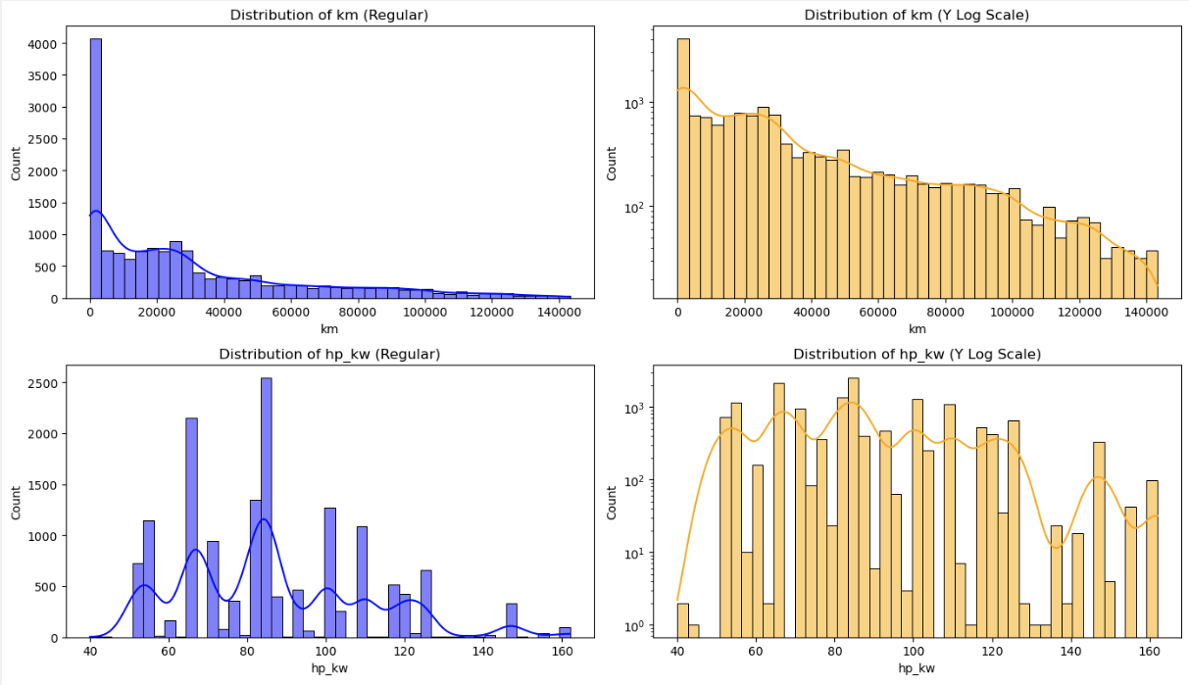

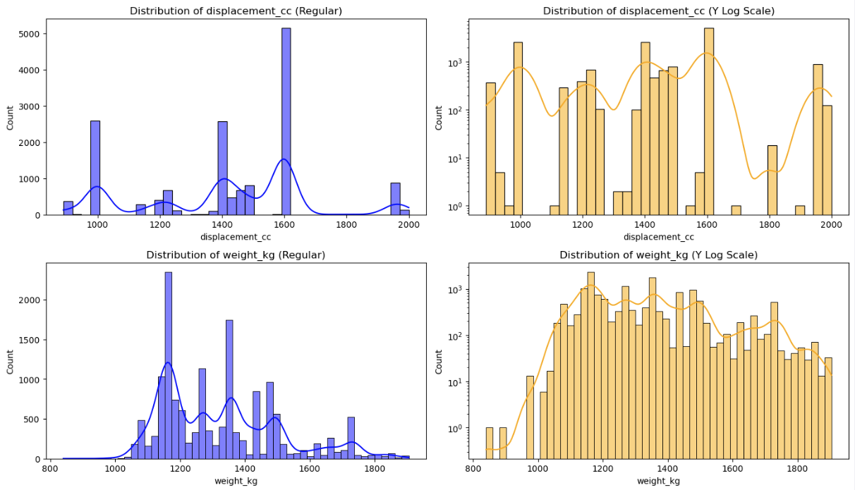

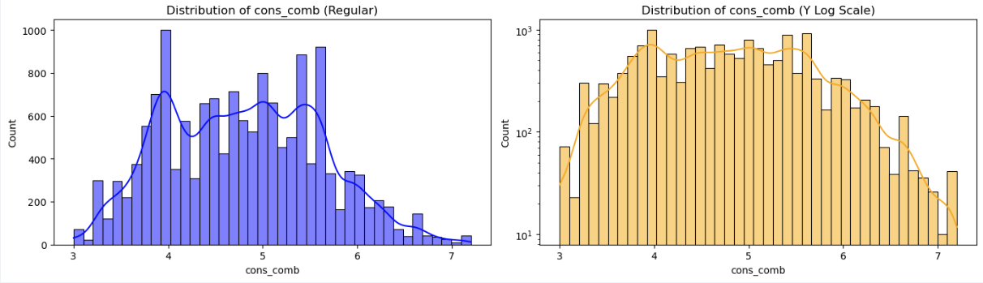

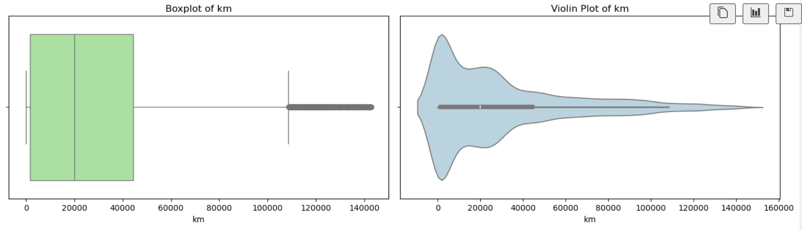

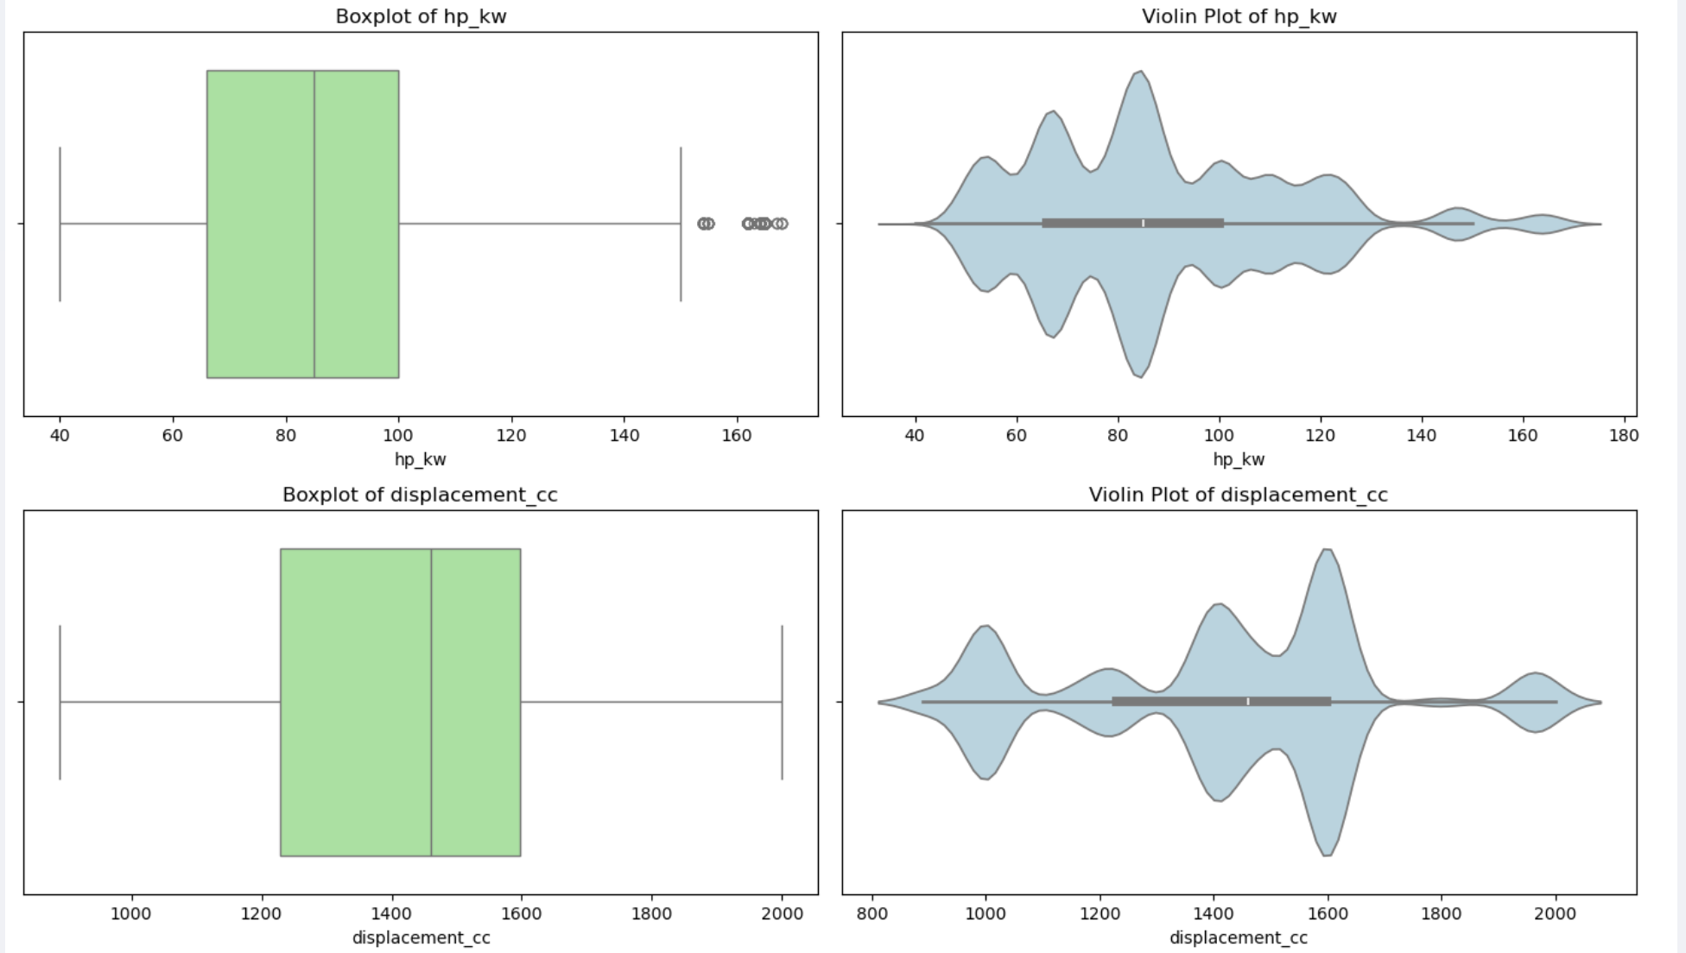

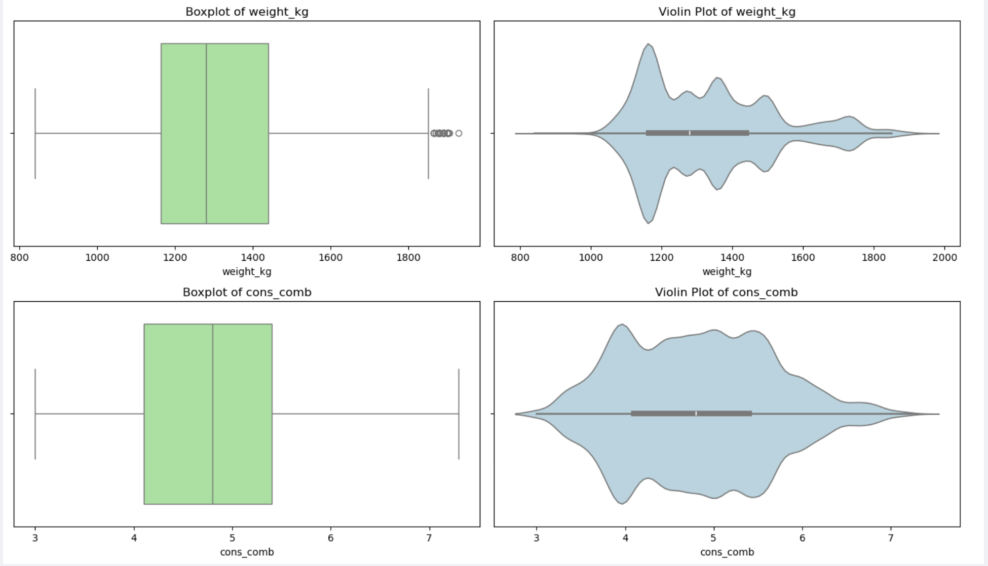

#### Data Quality Checks on Remaining Outliers

* Check if there are cars with age zero, but not new or high km
* Check if there are cars with km zero, but not new or high age
* Clean the outlier records
* Check for realistic value range for desired models for columns weight, displacement, horsepower, fuel consumption, age, mileage
* Check for any missing values, negative values, zero values and treat them
* Check for outliers using quantile and see if these are in small range (we have already applied z-score method for outlier removal)

---------------------------------------------------------------------------

---------------------------------------------------------------------------

Data Quality Checks Driven Cleanup - age

- There are 4336 cars with zero age which is valid for new cars.

- There are 1851 cars with zero age and high km.

- There are 1557 cars with zero age and type <> new.

- There are 899 cars with zero age, high km and type <> new.

- These records are likely data quality issues and will be removed.

Data Quality Counts Post Cleanup - age

- There are 1827 cars with zero age which is valid for new cars.

- There are 0 cars with zero age and high km.

- There are 0 cars with zero age and type <> new.

- There are 0 cars with zero age, high km and type <> new.

- These records are likely data quality issues and will be removed.

---------------------------------------------------------------------------

Data Quality Checks Driven Cleanup - km

- There are 19 cars with zero km which is valid for new cars.

- There are 0 cars with zero km and type <> new.

- There are 0 cars with zero km, age <> 0.

- These look like brand new cars, example the ones in showroom without usage, hence will be retained.

---------------------------------------------------------------------------

Checking for realistic value ranges for ['Audi A1', 'Audi A2', 'Audi A3', 'Opel Astra', 'Opel Corsa','Opel Insignia', 'Renault Clio', 'Renault Espace']

- Car weight should be positive

- Engine displacement should be positive

- Car weight should be between 600 and 3500 kg

- Displacement should be between 890 and 3000 cc

- Engine power (hp_kw) should be between 40 and 300 kW

- Combined fuel consumption (cons_comb) should be between 3 and 15 L/100km

- Car age should be between 0 and 30 years

- Car mileage (km) should be between 0 and 400,000 km

---------------------------------------------------------------------------

Post Outlier Treatment Summary Statistics (Min, Max, Missing, Negative, Zero counts):

- weight_kg: min=840.0, max=1929.0, missing=0, negative=0, zero=0

- displacement_cc: min=898.0, max=2000.0, missing=0, negative=0, zero=0

- hp_kw: min=40.0, max=167.0, missing=0, negative=0, zero=0

- cons_comb: min=3.0, max=7.3, missing=0, negative=0, zero=0

- age: min=0.0, max=3.0, missing=0, negative=0, zero=1827

- km: min=0.0, max=143000.0, missing=0, negative=0, zero=19

---------------------------------------------------------------------------

Check the outliers are realistic. Retain if valid and have real-world values. Check of records above 99th percentile for Weight, Displacement, HP and Fuel Consumption. Find out the mean values for these records, number of unique models, make model and check against real-world values.

Post Z-score Outlier Treatment - Records above 99th percentile:

---------------------------------------------------------------------------

- Weight (kg):

- Count of cars withWeight (kg) above 99th percentile: 110

- Average weight_kg of cars above 99th percentile: 1863.41 kg

- Number of Unique make_models above 99th percentile: 4

- Unique make_models above 99th percentile: ['Audi A3' 'Opel Astra' 'Opel Insignia' 'Renault Espace']

---------------------------------------------------------------------------

- Displacement (cc):

- Count of cars with Displacement (cc) above 99th percentile: 104

- Average displacement_cc of cars above 99th percentile: 1997.76 cc

- Number of Unique make_models above 99th percentile: 4

- Unique make_models above 99th percentile: ['Audi A1' 'Audi A3' 'Opel Insignia' 'Renault Espace']

---------------------------------------------------------------------------

- HP (kW):

- Count of cars with HP (kW) above 99th percentile: 113

- Average hp_kw of cars above 99th percentile: 164.76 kW

- Number of Unique make_models above 99th percentile: 2

- Unique make_models above 99th percentile: ['Renault Clio' 'Renault Espace']

---------------------------------------------------------------------------

- Fuel consumption (cons_comb):

- Count of cars with Fuel consumption (cons_comb) above 99th percentile: 51

- Average cons_comb of cars above 99th percentile: 7.05 L/100km

- Number of Unique make_models above 99th percentile: 3

- Unique make_models above 99th percentile: ['Opel Astra' 'Opel Corsa' 'Opel Insignia']

---------------------------------------------------------------------------

Post Outlier Treatment and Data Validation:

- All values of weight_kg, displacement_cc, hp_kw, cons_comb, age, km are within realistic ranges

- No missing or negative values in key columns weight_kg, displacement_cc, hp_kw, cons_comb, age, km

- There are few records above 99th percentile in Weight, Displacement, HP, fuel consumption which are valid high-end cars

|  |  |  |  |
| --- | --- | --- | --- |
| Feature | >99th Percentile Summary | Interpretation | Verdict |
| Weight (kg) | ~1,863 kg average among top 1%, seen in *Audi A3*, *Opel Astra*, *Insignia*, *Renault Espace* | Those are **mid-to-large sedans / MPVs**, which *naturally weigh 1.7–2.0 tons*. Nothing implausible here. | **Valid outliers** (keep) |
| Displacement (cc) | ~1,998 cc avg, *Audi A1/A3*, *Insignia*, *Espace* | 2.0 L engines are standard for premium trims. Definitely real data. | **Valid outliers** (keep) |
| HP (kW) | ~165 kW (≈ 220 HP), *Renault Clio*, *Espace* | High-performance trims exist (e.g., *Clio RS*, *Espace GT*). Values are within market reality (< 300 HP). | **Valid outliers** (keep) |
| Fuel consumption (L/100 km) | ~7.0 L/100 km, *Opel Astra/Corsa/Insignia* | 7 L/100 km is *normal to slightly high*, not erroneous. May indicate sporty engines or urban cycles. | **Valid outliers** (keep) |

## Feature Engineering

### Fix Redundant Columns and Create New Ones

* Create 3 new engineered features
  + Power_to_weight_ratio = hp_kw / weight_kg
  + Km_per_year = km / (age + 1)
  + Engine_efficiency = displacement_cc / hp_kw

Creating additional features:

- Created 'power_to_weight' feature as hp_kw [/](https://file+.vscode-resource.vscode-cdn.net/) weight_kg

- power_to_weight stats: min=0.0321, max=0.1490, mean=0.0648

- Created 'km_per_year' feature as km [/](https://file+.vscode-resource.vscode-cdn.net/) (age + 1) (if age > 0 else km)

- km_per_year stats: min=0.00, max=68000.00, mean=11181.03

- Created 'engine_efficiency' feature as displacement_cc [/](https://file+.vscode-resource.vscode-cdn.net/) hp_kw

- engine_efficiency stats: min=7.1357, max=36.5250, mean=17.3879

We will retain the original columns as well for modeling and see the impact of regularization techniques.

|  |  |  |  |
| --- | --- | --- | --- |
| Feature | Formula | Intuition | Why it can help |
| power_to_weight | hp_kw / weight_kg | Captures engine strength per mass (performance indicator). | Combines two correlated predictors into one ratio — Lasso may pick it instead of both. |
| km_per_year | km / (age + 1) | Measures usage intensity. | Differentiates older low-mileage vs. newer high-mileage cars — useful for model signal clarity. |
| engine_efficiency | displacement_cc / hp_kw | Rough inverse of engine tuning. | Optional — may not improve model, but adds interpretability and diagnostic value. |

While there are few highly correlated columns that can be removed, we will retain them for now and use Ridge and Lasso regression later

**One-hot Encoding**:

* Apply one-hot encoding on categorical variables using pd.get_dummies
* For the new columns generated, convert the boolean data type to integer

<class 'pandas.core.frame.DataFrame'>

Index: 12932 entries, 0 to 15913

Data columns (total 39 columns):

# Column Non-Null Count Dtype

--- ------ -------------- -----

0 price 12932 non-null int64

1 km 12932 non-null float64

2 gears 12932 non-null float64

3 comfort_convenience 12932 non-null object

4 entertainment_media 12932 non-null object

5 extras 12932 non-null object

6 safety_security 12932 non-null object

7 age 12932 non-null float64

8 previous_owners 12932 non-null float64

9 hp_kw 12932 non-null float64

10 inspection_new 12932 non-null int64

11 displacement_cc 12932 non-null float64

12 weight_kg 12932 non-null float64

13 cons_comb 12932 non-null float64

14 price_log 12932 non-null float64

15 power_to_weight 12932 non-null float64

16 km_per_year 12932 non-null float64

17 engine_efficiency 12932 non-null float64

18 make_model_Audi A2 12932 non-null int64

19 make_model_Audi A3 12932 non-null int64

...

37 gearing_type_Semi-automatic 12932 non-null int64

38 drive_chain_front 12932 non-null int64

dtypes: float64(12), int64(23), object(4)

### Analysis & Feature Engineering on Multi-Label Variables

* Analyze ['Comfort_Convenience', 'Entertainment_Media', 'Extras', 'Safety_Security'] columns
* Check unique values in each feature spec column
* For each multi-label categorical column:
  + Split values by comma, convert to a pandasSeries where each row is a list of features
  + Flatten all lists into a signle list all_features, to count occurrences of each feature
  + Keep only features present in >= threshold_percent of rows

comfort_convenience: 27 features retained out of 38 total

entertainment_media: 9 features retained out of 10 total

extras: 8 features retained out of 17 total

safety_security: 27 features retained out of 29 total

List of commonly used features retained in the columns:

{'comfort_convenience': ['Air conditioning',

'Armrest',

'Automatic climate control',

'Cruise control',

'Electrical side mirrors',

'Hill Holder',

'Leather steering wheel',

'Light sensor',

'Multi-function steering wheel',

'Navigation system',

'Park Distance Control',

'Parking assist system sensors rear',

'Power windows',

'Rain sensor',

'Seat heating',

'Start-stop system',

'Lumbar support',

'Tinted windows',

'Parking assist system sensors front',

'Split rear seats',

'Keyless central door lock',

'Electrically heated windshield',

'Parking assist system camera',

'Electrically adjustable seats',

'Electric tailgate',

'Heated steering wheel'],

'entertainment_media': ['Bluetooth',

'Hands-free equipment',

'On-board computer',

'Radio',

'Sound system',

'MP3',

'CD player',

'USB',

'Digital radio'],

'extras': ['Alloy wheels',

'Catalytic Converter',

'Voice Control',

'Sport seats',

'Sport suspension',

'Sport package',

'Touch screen',

'Roof rack'],

'safety_security': ['ABS',

'Central door lock',

'Daytime running lights',

'Driver-side airbag',

'Electronic stability control',

'Fog lights',

'Immobilizer',

'Isofix',

'Passenger-side airbag',

'Power steering',

'Side airbag',

'Tire pressure monitoring system',

'Traction control',

'Xenon headlights',

'Central door lock with remote control',

'Head airbag',

'Alarm system',

'Emergency system',

'LED Headlights',

'Adaptive headlights',

'LED Daytime Running Lights',

'Rear airbag',

'Emergency brake assistant',

'Adaptive Cruise Control',

'Traffic sign recognition',

'Lane departure warning system',

'Blind spot monitor']}

### Perform Multi-Label Feature Encoding

* For each multi-label categorical column:
  + Split values by comma, convert to a pandasSeries where each row is a list of features
  + Multi-hot encode using only common features identified in previous steps
  + Concatenate encoded columns and drop original

Encoded DataFrame shape: (12932, 106)

<class 'pandas.core.frame.DataFrame'>

Index: 12932 entries, 0 to 15913

Columns: 106 entries, price to safety_security_Blind spot monitor

dtypes: float64(8), int64(93)

memory usage: 9.9 MB

### Split Data into Training and Test

* Separate dependent and independent variables into X and y
* Retain target variable as price_log
* Retain original price column in a separate y_with_orig dataset for reference
* Create X_train, X_test, y_train_log, y_test_log dataframes using test size 0.2 and random state 42 (for consistency across runs)

Shape of X_train: (10345, 104), y_train: (10345,), X_test: (2587, 104), y_test: (2587,)

**Train-Test Split Inference**:

* The dataset was split into training (80%) and testing (20%) subsets using the log-transformed target (price_log).
* Both price and price_log columns were removed from the feature matrix X to avoid leakage.
* The original price column was retained separately (y_with_orig) for evaluation and inverse transformation during metric computation.
* A fixed random seed ensures reproducibility.

### Scale Features

#### Recommended workflow:

* Split data into train and test sets.
* Fit the scaler (e.g., StandardScaler, MinMaxScaler) only on the training data.
* Transform both train and test sets using the scaler fitted on the training data.
* Use the scaled data for all your models.
* Why?
  + Scaling before splitting can cause data leakage, leading to overly optimistic model performance.
  + Scaling after splitting ensures fair and realistic evaluation for all models.

#### When to use StandardScaler vs MinMaxScalar:

* Standard
  + Most features are continuous and roughly bell-shaped (normal distribution).
  + We are using models that assume standardized data (linear regression, logistic regression, SVM, etc.).
  + If we want to handle outliers more robustly (StandardScaler is less sensitive than MinMaxScaler).
* MinMaxScaler:
  + Your features have a known, fixed range and you want to scale everything to [0, 1].
  + You are using models that are sensitive to the scale of input (e.g., neural networks).
  + Your data does not have extreme outliers.

#### Scale Features

* Select StandardScalar() approach
* Fit scalar transform using X_train dataset
* Transform X_train and X_test using the fitted scalar

Shape of X_train_scaled, X_test_scaled : (10345, 104), (2587, 104)

**Scaling** **Inference**:

* Features were standardized using Z-score scaling (StandardScaler) to ensure all predictors have comparable influence on the regression coefficients.
* The scaler was fit on the training data and applied to the test data to prevent data leakage.

# Linear Regression Models

## Baseline Linear Regression Model

### Build Basic Linear Regression Model & Evaluate Performance

* Initialize LinearRegression() model
* Fit the model on X_train_scaled dataset
* Predict y_train_log_pred, y_test_log_pred using the fitted linear regression model
* Create a lr_coeff dataframe with features, coefficients, absolute(coefficients), sign
* Display top-N coefficients using absolute values
* Analyze model scores for both Train and Test data –
  + Inverse transform the log values to get the y actual and predicted values
  + R2, MSE, RMSE, MAE, MAPE using y_actual and y_predicted values
  + Variance, Standard Deviation, Mean using y_actual values

---------------------------------------------------------------------------

Top 10 Coefficients with sign

---------------------------------------------------------------------------

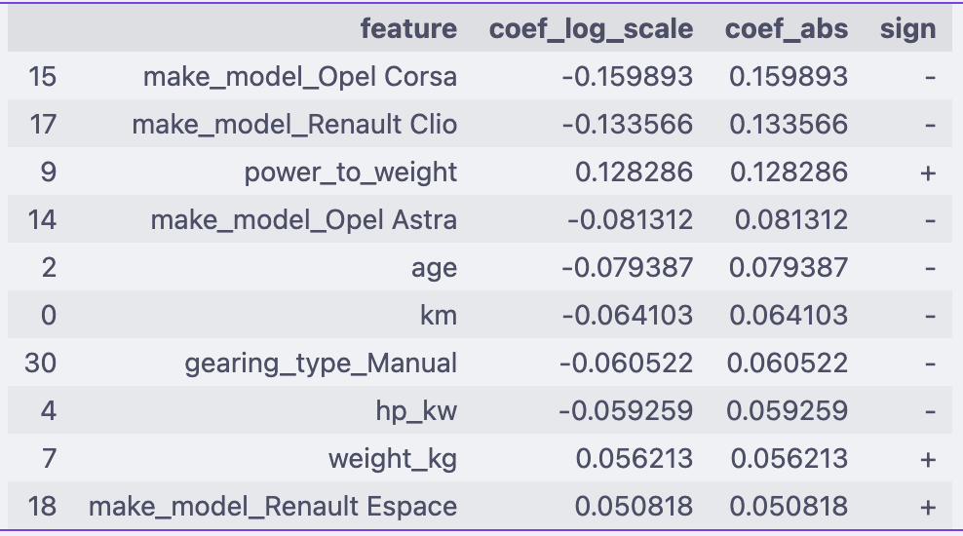

---------------------------------------------------------------------------

Bottom 10 Coefficients with sign

---------------------------------------------------------------------------

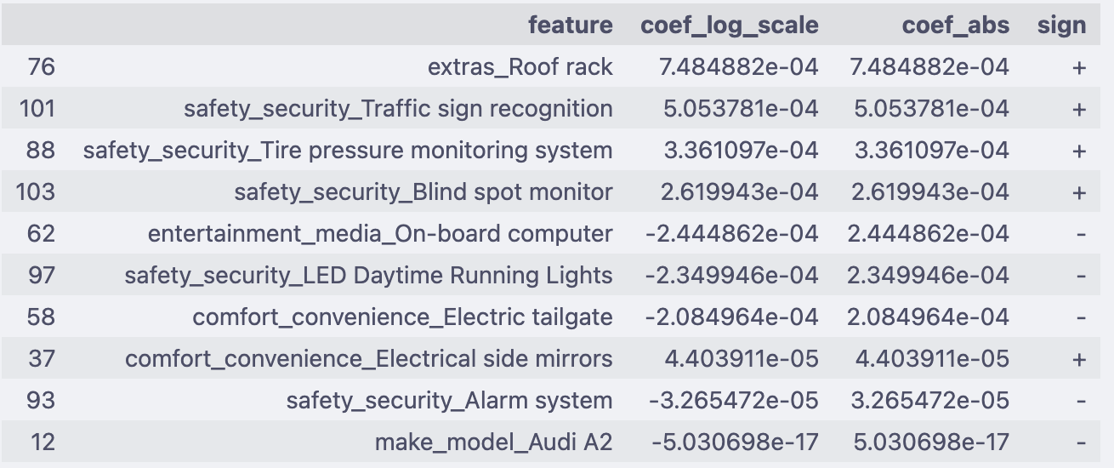

---------------------------------------------------------------------------

Analyze Model Performance (on original scale) – Baseline Linear Regression

---------------------------------------------------------------------------



#### Analysis of baseline model

* **rmse < std: Good**. Our model’s error is less than the standard deviation of the actual values, meaning it’s better than just predicting the mean.
* **mse < var for train and test: Good**. The model’s mean squared error is less than the variance of the actuals, indicating it’s capturing signal.
* **mae < mean for train and test: Good**. The average error is much less than the average value, so your predictions are reasonably close.
* **r2 > 0.89 for both and close: Very good**. High and similar R² on train and test means your model is both accurate and generalizes well.

|  |  |  |  |
| --- | --- | --- | --- |
| Metric | Train | Test | Interpretation |
| RMSE | 1,890 | 1,907 | Average price prediction error ~1.9K — remarkably low relative to mean price (~16.9K). Indicates excellent fit. |
| MAE | 1,210 | 1,222 | Mean absolute error around 1.2K — predictions are tightly clustered around actual values. |
| R² | 0.91 | 0.906 | Model explains ~91% of variance in price — very strong baseline performance. |
| MAPE | 7.0% | 7.1% | Predictions are within ±7% of actual price — highly acceptable for car pricing models. |
| Train vs Test | Close across all metrics | | Indicates minimal overfitting — scaling, transformations, and encoding are working effectively. |

#### Summary:

* Model is performing well overall.
* Keep an eye on the gap between train and test metrics; if it grows, consider regularization or more data.

### Analyze Residuals

* Inverse transform to get original y values for y_train and y_test
* Find residuals for trained data (y_train – y_train_pred)
* Find residuals for test data (y_test – y_test_pred)
* Residuals vs Predicted targets values chart
  + Scatter plot of y predicted values vs residuals of trained data
  + Overlay scatter plot of y predicted values vs residuals of test data
* Residuals distribution chart
  + Histogram of residuals of trained data
  + Overlay histogram with residuals of test data

Baseline Model - Plot of Residuals vs Predicted (on original scale):

---------------------------------------------------------------------------

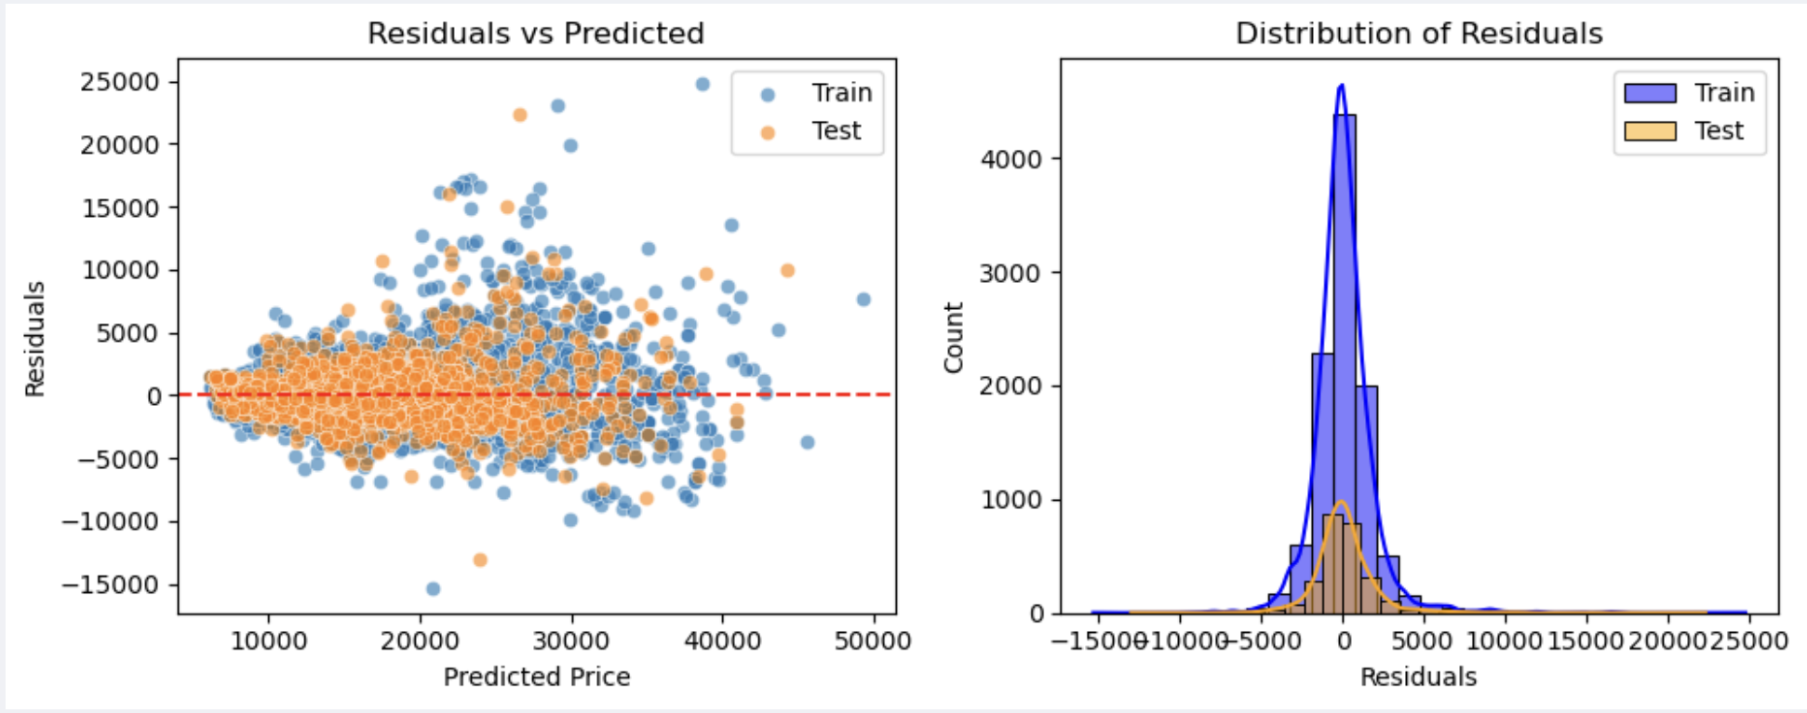

**Residual Plots** **Interpretation**:

* Mean of residuals is zero
* Spread looks symmetric (no skew)
* No clear pattern (e.g., residuals increasing only for certain predicted price ranges).
* Distribution of residuals is normal for train and test both

### Check Multicollinearity using Variance Inflation Factor (VIF)

* Create a DataFrame to store VIF results.
* Add a column intercept using a constant value
* For each feature (including the constant intercept), calculates the Variance Inflation Factor (VIF) using variance_inflation_factor function.
* VIF measures how much a feature is linearly predicted by the other features (i.e., multicollinearity).
* How VIF works:
  + For each feature, it fits a regression model predicting that feature from all the others.
  + VIF = 1 / (1 - R²) from that regression.
  + High VIF (>5 or >10) means the feature is highly collinear with others

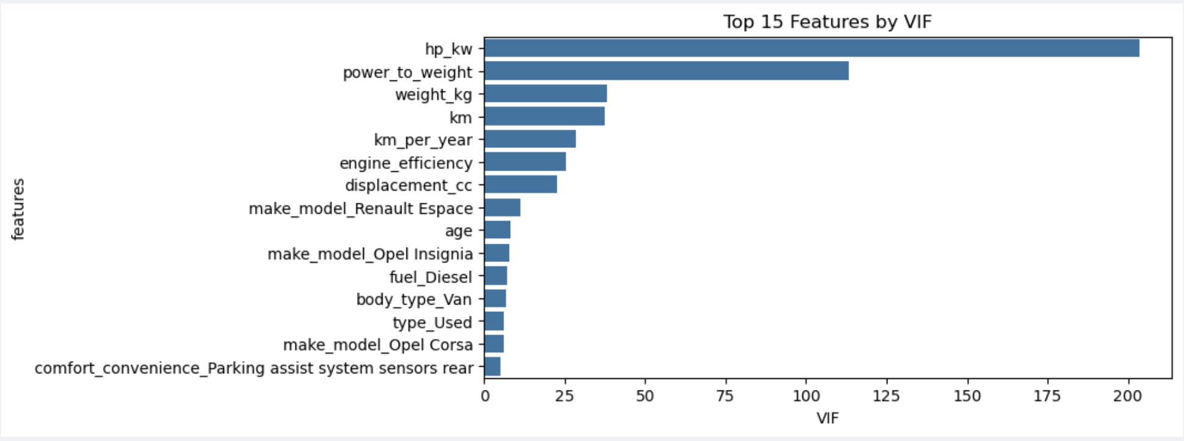

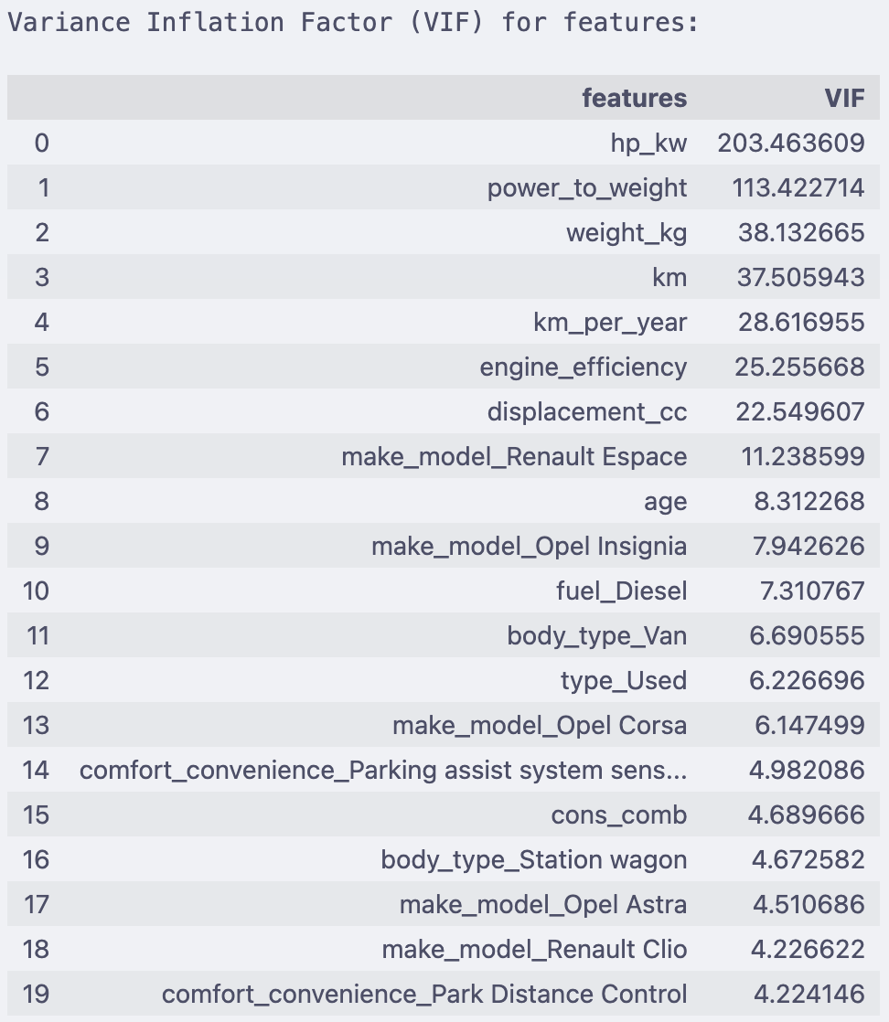

#### Interpretation

* VIF < 5 → Fine
* 5 ≤ VIF < 10 → Moderate multicollinearity, keep an eye
* VIF ≥ 10 → Strong multicollinearity, consider fixing

|  |  |  |
| --- | --- | --- |
| Feature | VIF | Interpretation |
| hp_kw | 203.46 | Extremely high — strongly collinear with power_to_weight, weight_kg, and displacement_cc. Represents core engine power relationship. |
| power_to_weight | 113.42 | Severe redundancy with both hp_kw and weight_kg. Derived feature amplifies existing relationship. Ridge/Lasso will handle. |
| weight_kg | 38.13 | High multicollinearity — tied to both horsepower and displacement; heavier cars generally have higher engine output. |
| km | 37.51 | Very high collinearity with age and km_per_year; these variables capture overlapping vehicle usage information. |
| km_per_year | 28.62 | Derived feature — strongly correlated with both age and km. Leave for now; regularization will address redundancy. |
| engine_efficiency | 25.26 | High — computed from hp_kw and displacement_cc; naturally interdependent. Retain for interpretability but watch VIF. |
| displacement_cc | 22.55 | High collinearity with hp_kw and engine_efficiency. Both capture aspects of engine capacity. |
| make_model_Renault Espace | 11.24 | High — overlaps with body_type_Van (most Espace are vans) and higher weights. |
| age | 8.31 | Moderate — correlates with km and km_per_year; expected due to vehicle usage linkage. |
| make_model_Opel Insignia | 7.94 | Moderate — overlaps with other Opel model dummies and related body types. |
| fuel_Diesel | 7.31 | Moderate — associated with larger engines (hp_kw, displacement_cc, cons_comb). |
| body_type_Van | 6.69 | Moderate — correlates with make_model_Renault Espace; redundancy expected. |
| type_Used | 6.23 | Moderate — correlates with age and km; used cars are typically older and have higher mileage. |
| make_model_Opel Corsa | 6.15 | Moderate — overlaps with other Opel dummies and smaller engine specs. |
| comfort_convenience_Parking assist… | 4.98 | Acceptable — slight correlation with other comfort features (e.g., Park Distance Control). |
| cons_comb | 4.69 | Acceptable — moderate correlation with engine size and efficiency. |
| body_type_Station wagon | 4.67 | Acceptable — overlaps with specific models (Astra wagon, Renault Espace). |
| make_model_Opel Astra | 4.51 | Acceptable — moderate overlap with other Opel dummies and body types. |
| make_model_Renault Clio | 4.23 | Acceptable — some overlap with Renault brand effects but within safe limits. |
| comfort_convenience_Park Distance Control | 4.22 | Acceptable — overlaps with other parking-assist-related features but low impact. |

**Muti-Collinearity** **Interpretation Summary**:

* Multicollinearity is severe among engine-related and derived numerical features but moderate to low elsewhere.
* This is an expected outcome after introducing interaction-style engineered variables.
* No manual feature removal was performed — subsequent Ridge and Lasso regression models will regularize and shrink redundant predictors automatically, ensuring model stability and interpretability.

## Ridge Regression Implementation

### Define Alpha Values

* We will start with alpha range of alpha_range = [0.01, 0.1, 1, 10, 50, 100, 200, 300, 400, 500]

### Apply Ridge Regression, Analyze Performance & Find Best Alpha Value

#### Apply Ridge Regression

* Function to fit a RidgeCV model to the training data and returns predictions for both train and test sets. Also returns the chosen alpha value
* Use RidgeCV with *cv=KFold(n_splits=5, shuffle=True, random_state=42)*
  + *cv=5 is same as default KFold(n_splits=5, shuffle=False)*
  + *cv=KFold(n_splits=5, shuffle=True, random_state=42) => This explicitly creates a KFold cross-validator with 5 splits,*
  + *shuffle=True randomizes the order of the data before splitting, especially needed if your dataset is ordered*
  + *random_state=42 ensures reproducibility (the same splits every time you run)*
* Fit the model on trained data
* Predict the target values on train and test data both
  + Y_train_log_ridge_pred
  + Y_test_log_ridge_pred
* Use this model to identify the chosen alpha, which will later be used for narrowing the range

#### Analyze Model Performance & Identify Chosen Alpha

* Use the reusable function defined earlier to calculate and compare the model metrics for train and test data
* Use the reusable function defined earlier to chart
  + Residuals vs Predicted plot
  + Distribution of Residuals

RidgeCV Model - Analyze Model Performance (on original scale):

---------------------------------------------------------------------------



---------------------------------------------------------------------------

RidgeCV Model - Plot of Residuals vs Predicted (on original scale):

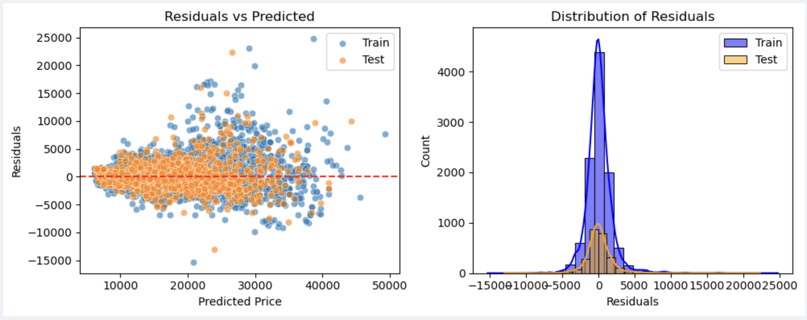

#### Plot Error-Alpha chart

* Since RidgeCV does not store the scores for each CV fold, we will calculate this using Ridge() and save the train and test scores of each run of alpha
  + Initialize Ridge() model
  + Fit the model on training data
  + Apply the model on training and test data to predict training scores and validation scores
  + Apply cross validation score method using “neg_mean_absolute_error”
  + Plot the line graph of alpha on x-axis vs training/ testing scores on y-axis

Best alpha based on CV validation MAE: 0.01

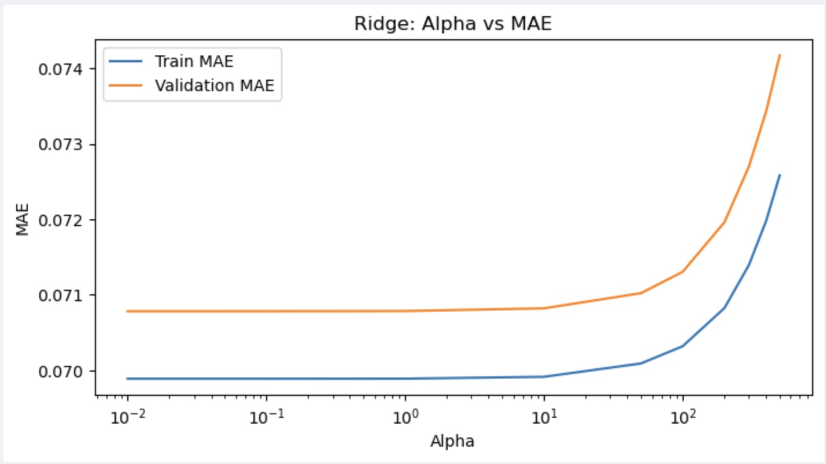

#### Find Chosen Alpha Value

* Identify Chosen alpha value using ridge.coef_ identified in 3.2.2.1
* This is based on RidgeCV model outcome

---------------------------------------------------------------------------

Chosen alpha (Ridge): 0.01

We will get some best value of alpha above. This however is not the most accurate value but the best value from the given list. Now we have a rough estimate of the range that best alpha falls in. Let us do another iteration over the values in a smaller range.

### Fine Tune Alpha, Analyze Performance, Error-Alpha Chart, Coefficients

* We will narrow down the alpha range around the chosen alpha value from 3.2.2.4
* narrow_alpha_range = np.*linspace*(0.01, 10, 100) # 100 values between 0.01 and 10
* Run the resusable function ridgecv model using the narrow alpha range
* Analyze the model performance on train and test data
  + Plot residuals vs predicted chart
  + Plot distribution
* Find the best ridgeCV alpha value for Test data and corresponding “mean_absolute_error”
* Using the reusable function defined earlier, plot the error-alpha chart.
* Show the coefficients for top and bottom k features
  + Features: X_train.columns
  + Coef: ridge.coef_
  + Coef_abs : absolute value of ridge.coef_
  + Sign : + or -ve based on Coef

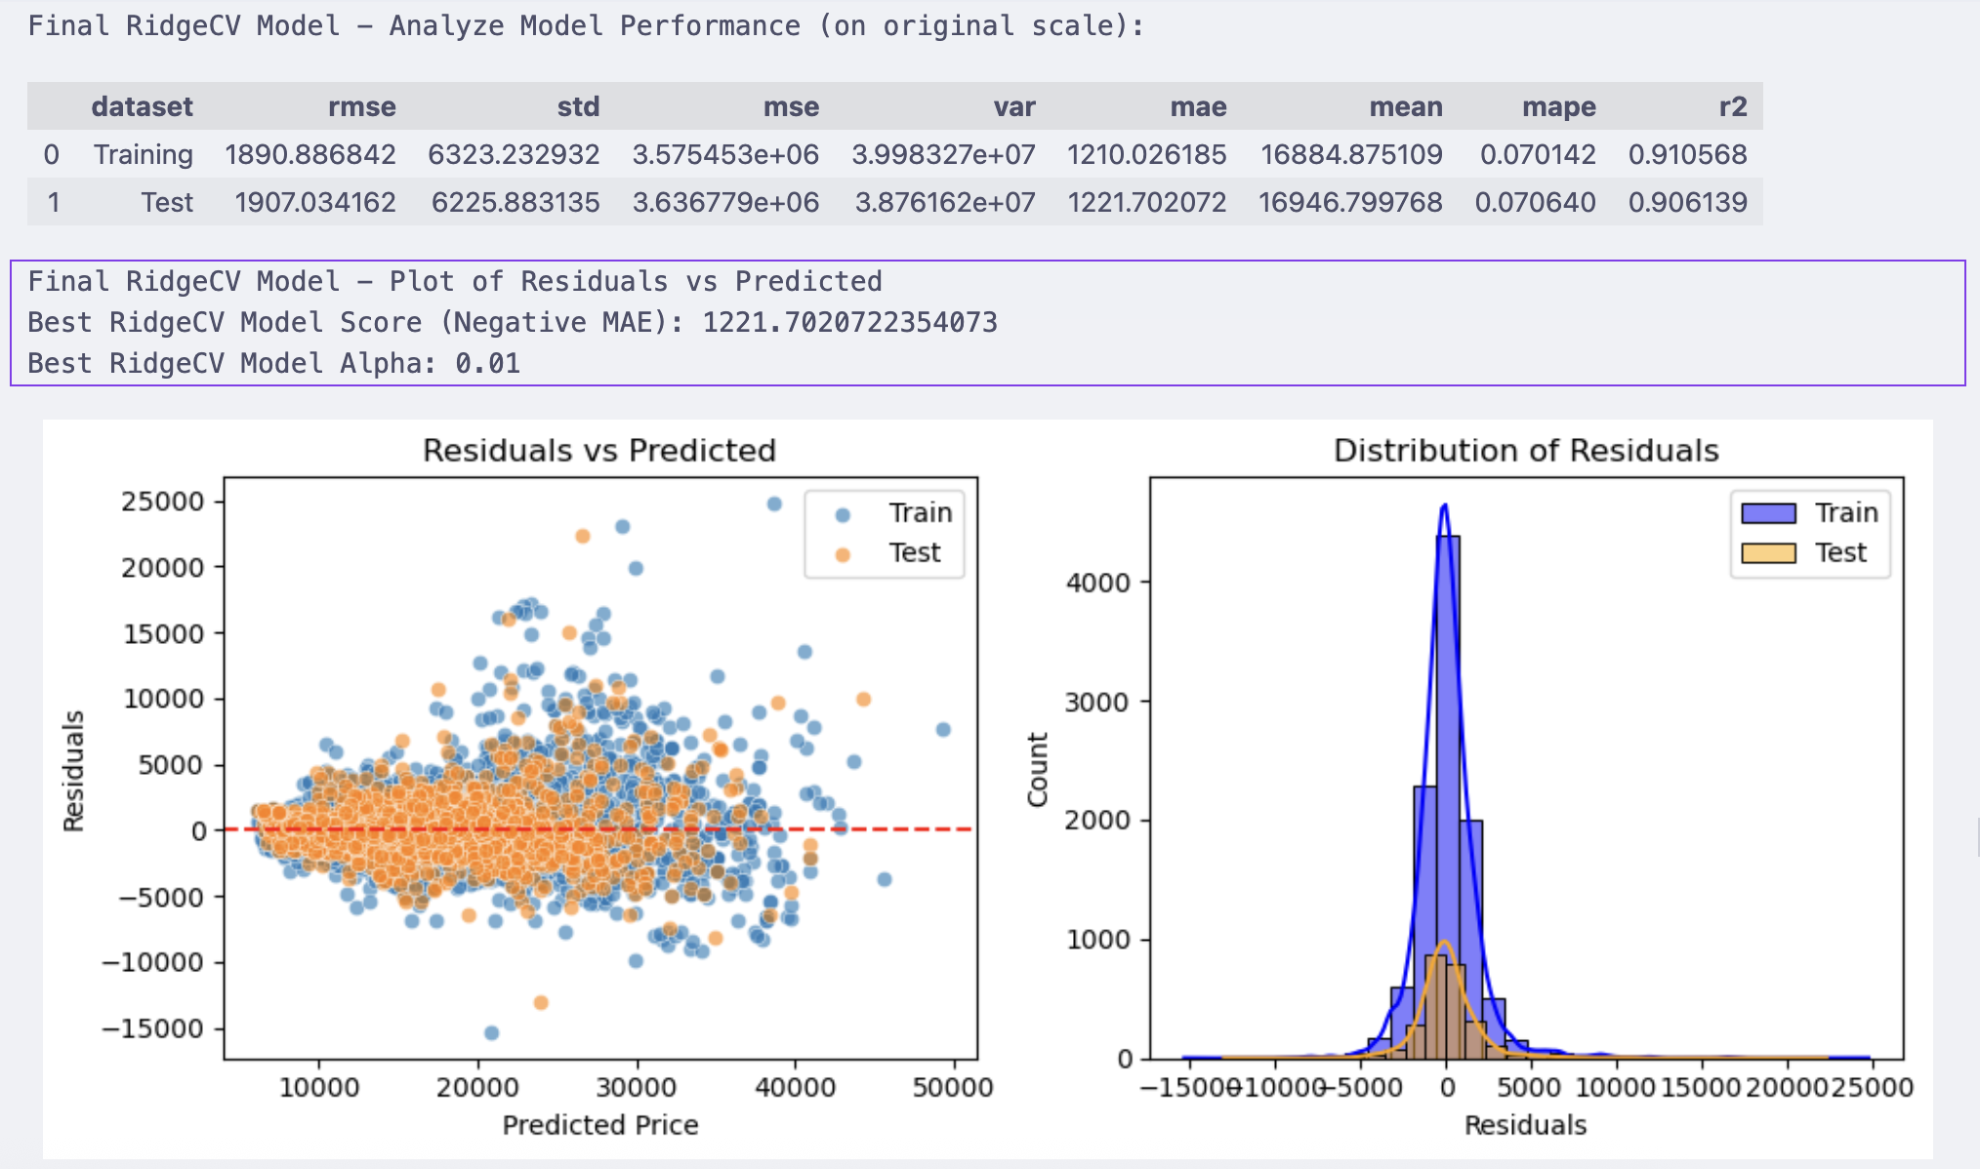

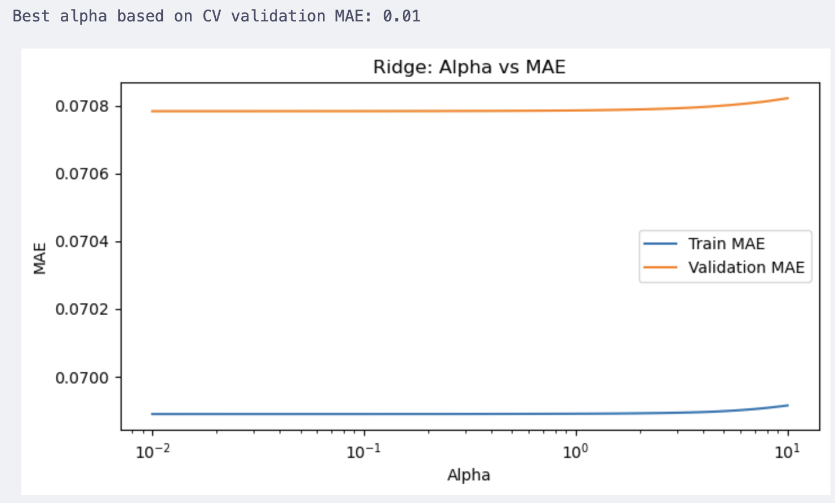

Since the alpha range is narrow, the MAE line is almost flat.

--------------------------------------------------------------------------

Final Ridge Model Coefficients with best score alpha=0.01

--------------------------------------------------------------------------

Since the model was trained on log-transformed prices, the coefficients represent the

percentage change in price (approximately) for a one-standard-deviation increase in

the respective feature, holding others constant.

---------------------------------------------------------------------------

Top 10 Coefficients with sign

---------------------------------------------------------------------------

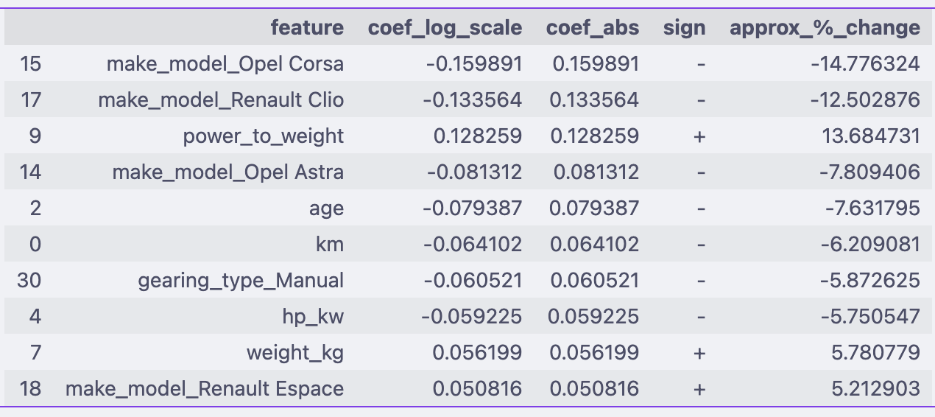

---------------------------------------------------------------------------

Bottom 10 Coefficients with sign

---------------------------------------------------------------------------

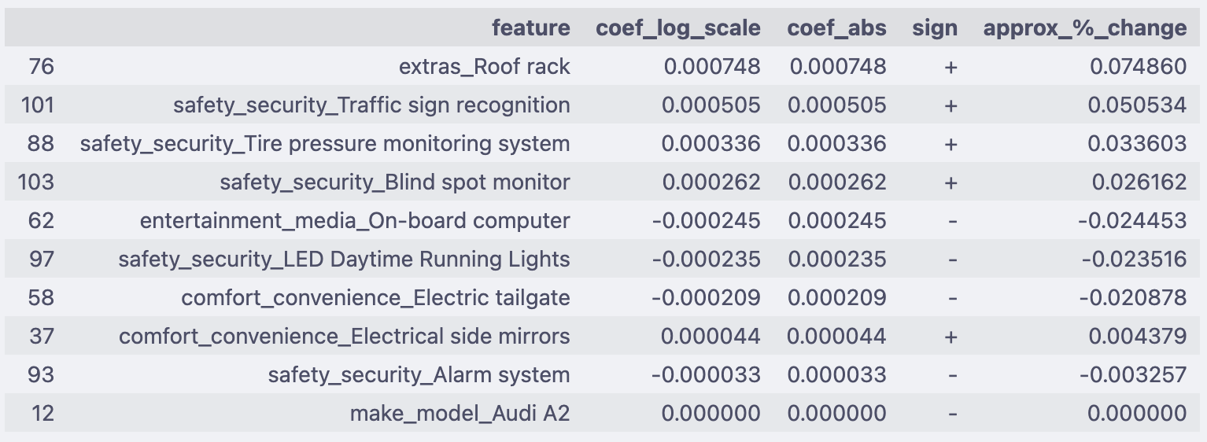

### Evaluate the Ridge Model on Test Data

* Display the summary values from test data model performance

Final Test Evaluation:

R²: 0.9061

MAE: 1221.70

MSE: 3636779.29

RMSE: 1907.03

### Ridge Model Interpretation Summary

|  |  |  |  |
| --- | --- | --- | --- |
| Metric | Train | Test | Interpretation |
| RMSE | 1890.9 | 1907.0 | Same as baseline — stable fit |
| MAE | 1210.0 | 1221.7 | Identical to OLS |
| R² | 0.911 | 0.906 | Identical to OLS |

**Validation behavior**: Validation MAE increased beyond α ≈ 10, confirming that higher regularization leads to underfitting.

**Inference:**

* Ridge regularization did not improve predictive performance, which indicates:
  + The data has no severe overfitting issue.
  + Multicollinearity is present (seen in high VIF values), but it doesn’t harm predictive accuracy significantly.
* Ridge provides coefficient stability rather than performance gains.

## Lasso Regression Implementation

### Define Alpha Range

We will start with alpha range of [ 0.01, 0.1, 1, 10, 20]

### Apply Lasso Regularization, Find Chosen Alpha, Analyze Model Performance

#### Apply Lasso Regularization

Fits Lasso models for a range of alpha values and returns train and test MSE scores along with the number of features used (non-zero coefficients) for each alpha. We will compare this with the best alpha coming from LassoCV. Since LassoCV uses MSE by default for hypertuning, we will use the same here.

* For each value of alpha in the range
  + Initialize Lasso() model
  + Fit the model on training data
  + Predict the y target on training and test data both (use the log values)
* Find the train and test scores using mean_squarred_error
* Apply Lasso Regularisation and find the best value of alpha from the list

|  |  |  |
| --- | --- | --- |
| Score Type | Computed on | Purpose |
| train_scores | Training data | Measures how well the model fits the data it was trained on. |
| val_scores | Cross-validation folds (inside training set) | Evaluates how well the model generalizes during hyperparameter tuning. |
| test_scores | Independent test set | Assesses final model performance on truly unseen data. |

#### Plot Error-Alpha chart

* Plots the training and testing MAE scores against alpha values for Lasso regression.
* Also plots the number of features used against alpha values.

Train MSE: [0.01139, 0.05998, 0.13925, 0.13925, 0.13925]

Validation MSE: [0.01146, 0.06002, 0.13926, 0.13926, 0.13926]

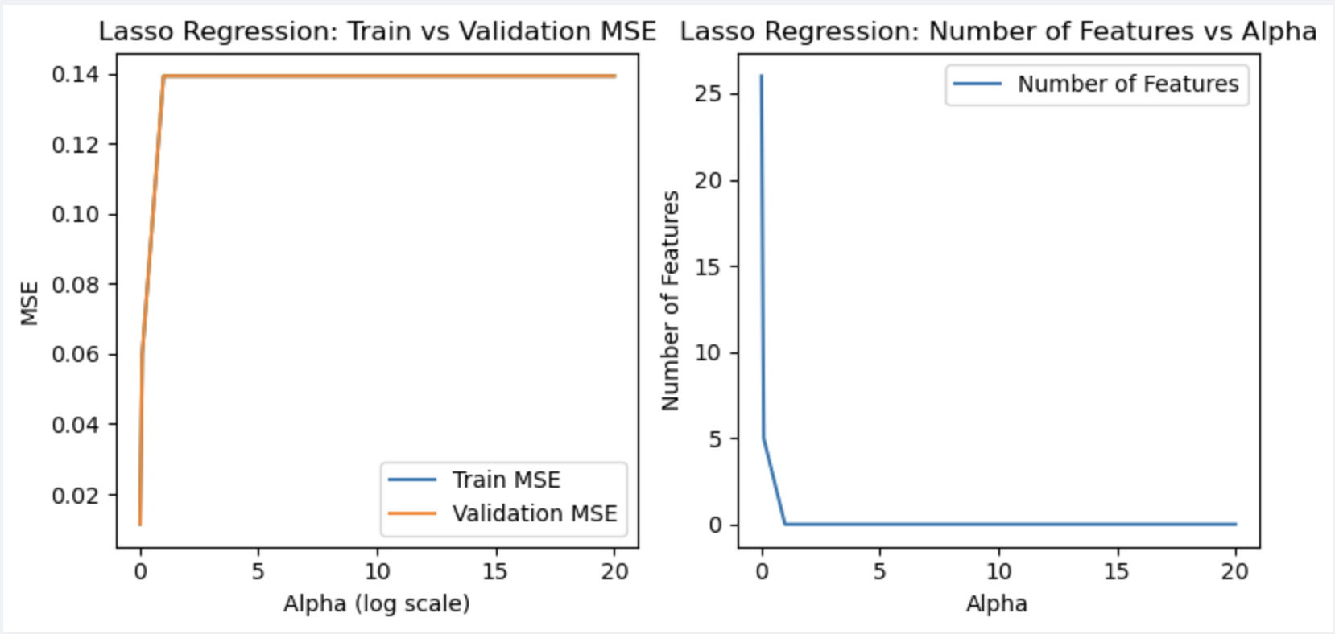

**Interpretation**:

* Train and Validation MSE almost overlap, thus looking like a single line
* Number of features drops to zero quickly with alpha close to 1

#### Find the Chosen Alpha

* Select the alpha such that the test scores are minimum

We use min Test MSE, to compare with LassoCV later which by default uses MSE

Chosen alpha (Lasso): 0.01

Chosen alpha (Lasso) with minimum Test MSE: 0.01, Test MSE: 0.011708

### Fine Tune with Narrow Alpha Range

* We use narrow alpha range : np.linspace(0.005, 0.1, 30) # 30 values between 0.005 and 10
* Fit a LassoCV model to the training data and returns predictions for both train and test sets. Also returns the chosen alpha value
* Initialize LassoCV with narrow alpha range and *cv*=*KFold*(*n_splits*=5, *shuffle*=True, *random_state*=42)
  + There is no scoring parameter in LassoCV, it uses MSE by default
  + cv=5 is same as default KFold(n_splits=5, shuffle=False)
  + cv=KFold(n_splits=5, shuffle=True, random_state=42)
    - shuffle=True randomizes the order of the data before splitting
    - random_state=42 ensures reproducibility (the same splits every time you run)
* Fit the model on training data
* Predict y, for train and test datasets: y_train_lasso_log_pred, y_test_lasso_log_pred
* Inverse transform the predictions to get y values on original scale
* Find best alpha using lassocv.alpha_
* Find best score MAE and MSE for the test predicted and test actual values
* Analyze model performance using the reusable function
* Plot the train and test scores for narrow alpha range using the reusable function

Final LassoCV Model - Analyze Model Performance (on original scale):

Best alpha (using LassoCV): 0.005

Test MAE (original scale): 1301.57, RMSE: 2056.93, MSE: 4230953.61 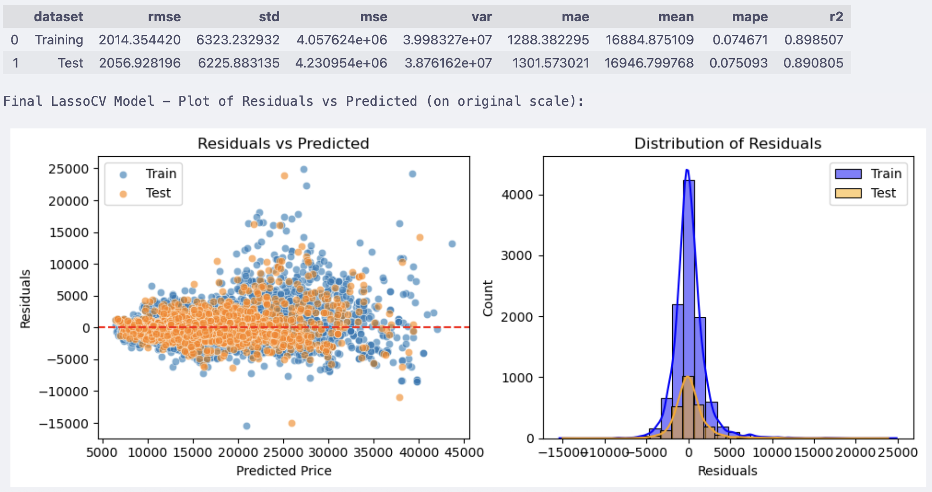

Plot the train and test scores using lasso() tuning and min negative MSE

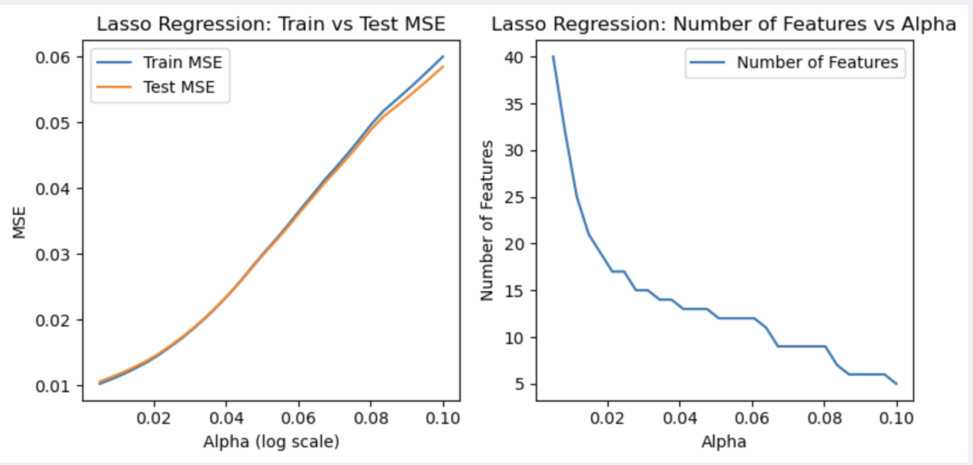

#### Run the Model using Best Alpha

Best alpha (using LassoCV): 0.005

Test MAE (original scale): 1301.57, RMSE: 2056.93, MSE: 4230953.61

Final LassoCV Model - Analyze Model Performance (on original scale):



Since the model was trained on log-transformed prices, the coefficients represent the

percentage change in price (approximately) for a one-standard-deviation increase in

the respective feature, holding others constant.

Since the model was trained on log-transformed prices, the coefficients represent the

percentage change in price (approximately) for a one-standard-deviation increase in

the respective feature, holding others constant.

---------------------------------------------------------------------------

Top 10 Lasso features and coefficients, with sign

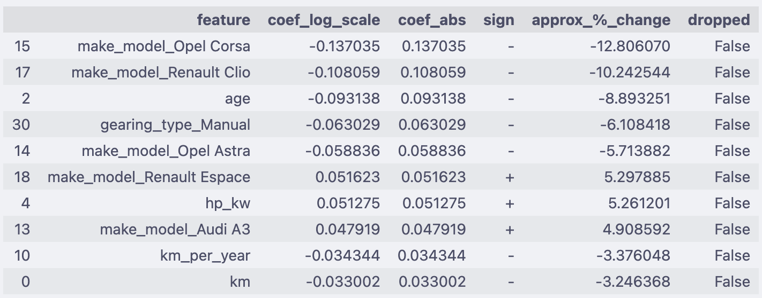

---------------------------------------------------------------------------

Bottom 10 Lasso features and coefficients, with sign

---------------------------------------------------------------------------

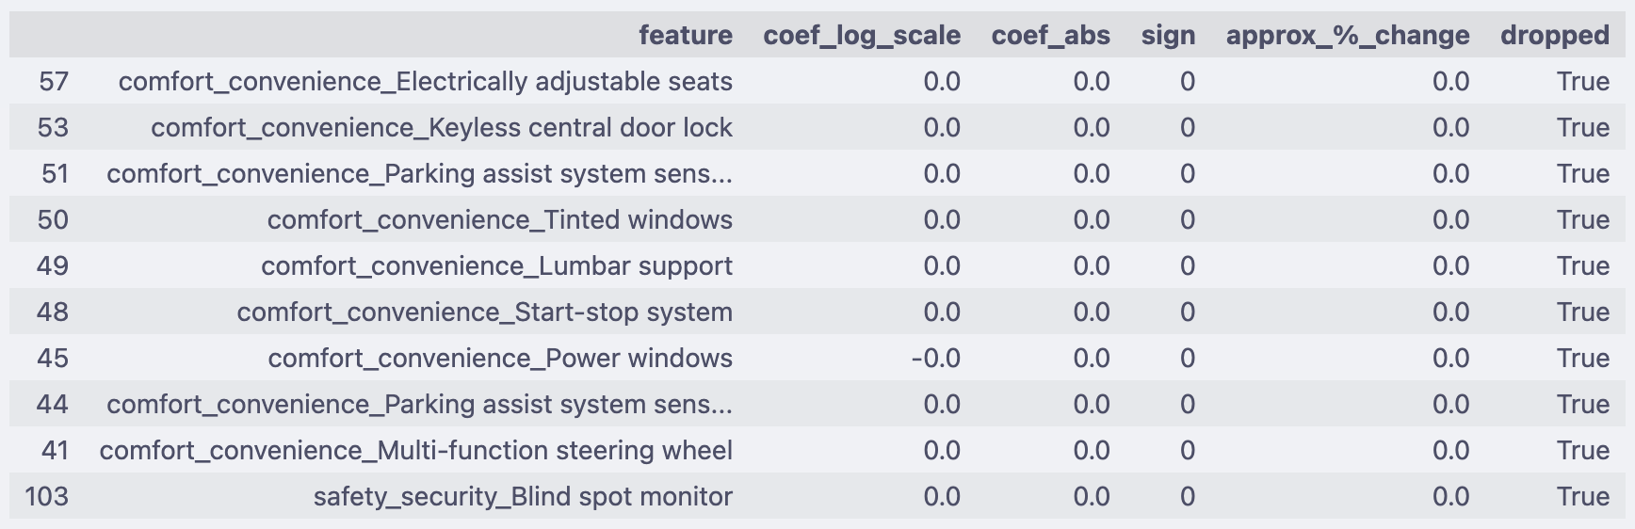

---------------------------------------------------------------------------

Dropped Lasso features and coefficients

---------------------------------------------------------------------------

Total features dropped (coeff=0): 64 out of 104

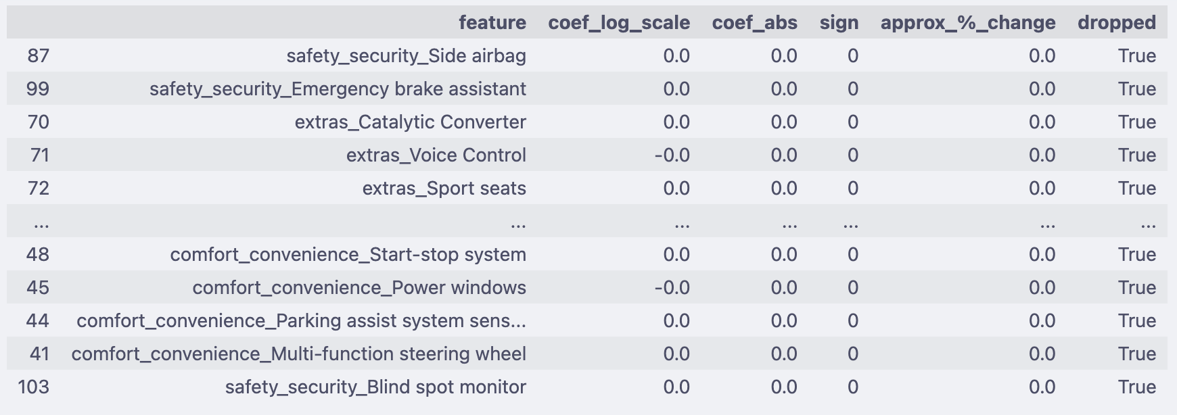

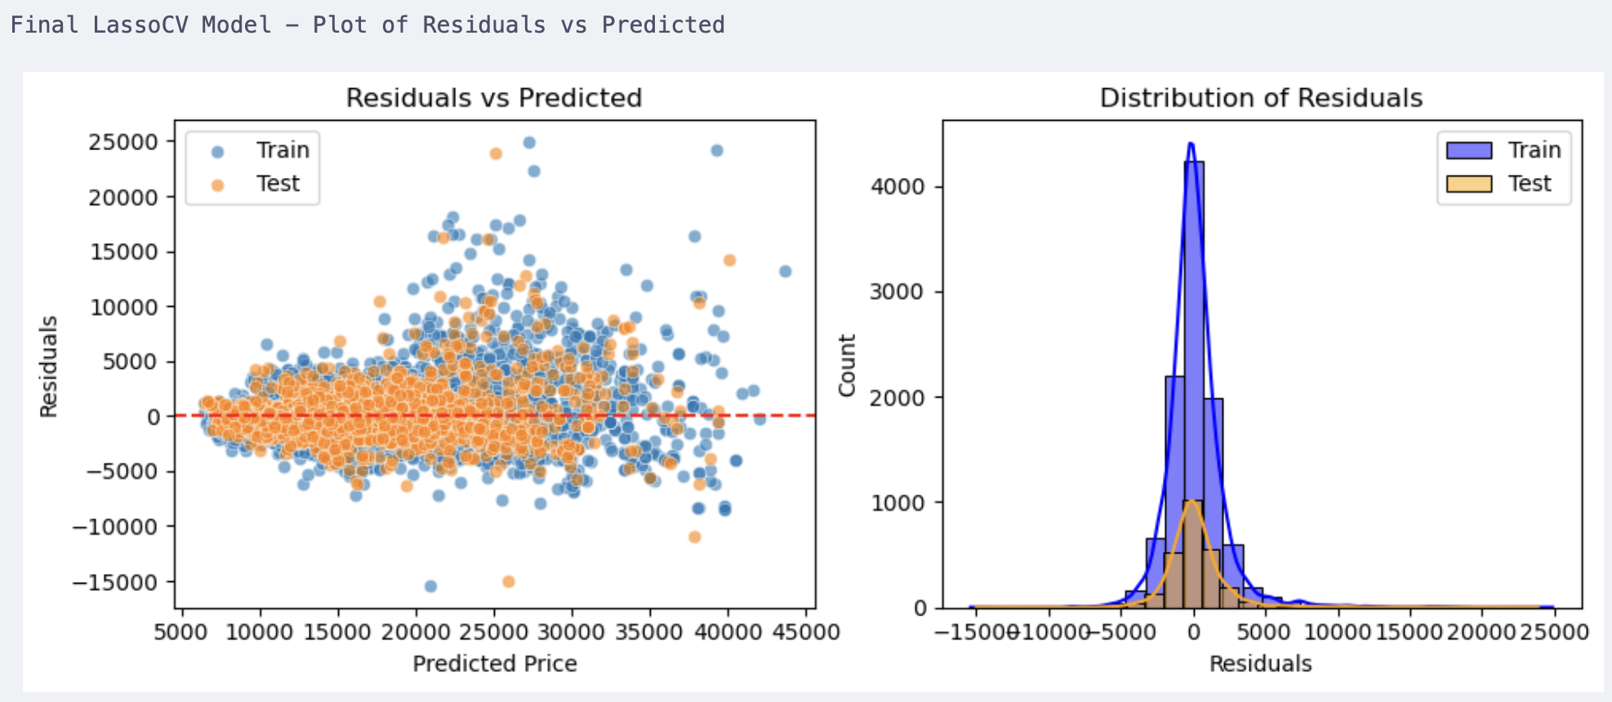

---------------------------------------------------------------------------

Lasso Coefficient Path Visualization

visualize how coefficients shrink as α increases:

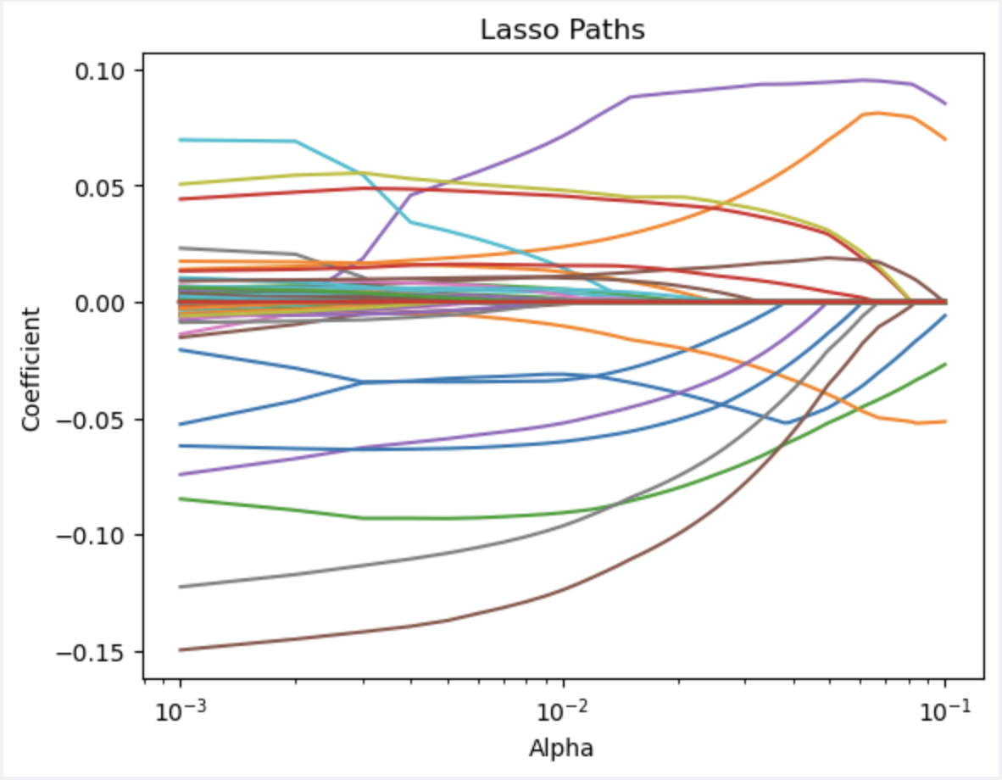

### Evaluate Lasso Model on Test Data

* Print the test data evaluation summary

Final Test Evaluation:

R²: 0.8908

MAE: 1301.57

MSE: 4230953.61

RMSE: 2056.93

### Lasso Model Inference Summary:

|  |  |  |  |
| --- | --- | --- | --- |
| Metric | Training | Test | Interpretation |
| RMSE | 2014.35 | 2056.93 | Prediction error ~2000 on average, consistent across train/test → minimal overfitting. |
| MAE | 1288.38 | 1301.57 | Typical prediction error ≈ 1300, showing good generalization. |
| R² | 0.8985 | 0.8908 | Model explains ~89% of price variability — excellent for a sparse linear model. |

**Interpretation Summary**

* Lasso regression delivered a highly interpretable, parsimonious model that retained ~40 key predictors explaining 89% of the price variation.
* It successfully eliminated redundant comfort and safety features while maintaining strong predictive performance comparable to Ridge and Linear models.
* Dominant predictors include model type (Opel, Renault, Audi), age, horsepower, gear type, and annual mileage, all intuitively aligned with real-world car valuation drivers.

**Best α (regularization strength): 0.005**

1. → A relatively low alpha, meaning only mild regularization was required.
2. The model still benefits from L1 shrinkage while retaining key predictors.
3. MSE (Test): 4.23M, consistent with Ridge and Linear results — confirming stable variance–bias balance.

**Feature Selection Behavior**:

* Total features in model: 104
* Features retained (non-zero coefficients): 40
* Features dropped (set to zero by L1 penalty): 64

This confirms that Lasso performed strong feature selection, removing ~61% of predictors. Most dropped variables were comfort, extras, and safety features, which are either:

* Highly correlated with brand/model, or
* Low-variance binary indicators that don’t independently explain price variation.

## Regularization Comparison & Analysis

### Compare Evaluation Metrics of Each Model

* Get the 3 output datasets from analyze model performance function for the respective LR, RIDGECV and LASSOCV models
* Add 2 columns with hold the name of the model and respective best alpha scores
* Combine the datasets and display the metrics

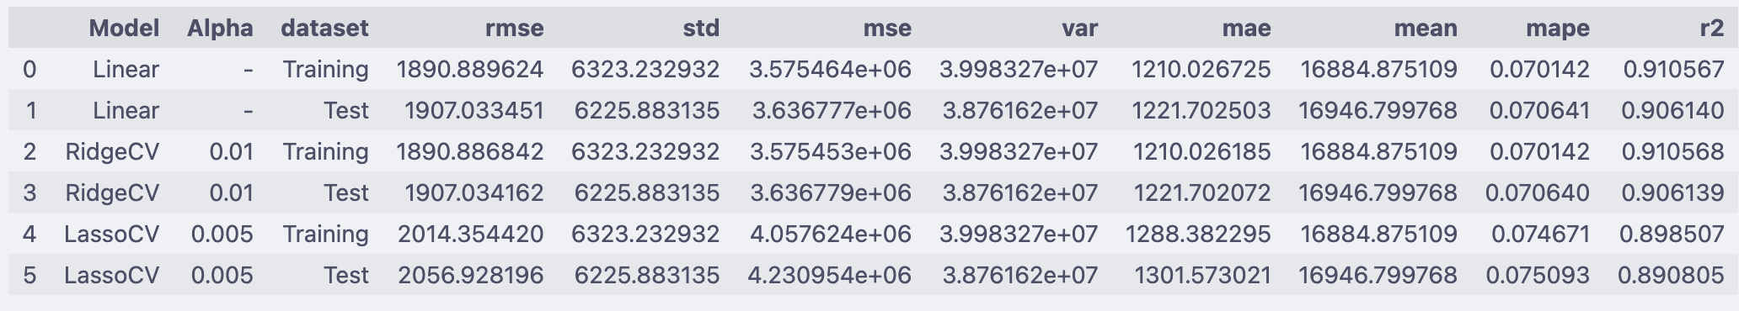

#### Interpretation of Combined Metrics

* All three models perform exceptionally well, achieving R² ≈ 0.89–0.91, meaning they explain ~90% of the variance in car prices.
* RMSE values around 1,900–2,000 indicate that the models predict car prices within roughly ±2,000 on average.
* MAE is between 1,200–1,300, meaning the typical deviation between predicted and actual prices is around 6–8% of the mean car price (~17,000).
* The near-identical training and test metrics across all models show excellent generalization — no signs of overfitting or underfitting.
* If Linear Regression has the lowest test error → data is not very multicollinear, and regularization doesn’t add much.
* If Ridge improves test performance slightly but reduces variance → multicollinearity was an issue, Ridge is stabilizing coefficients.
* If Lasso performs better (or gives similar error with fewer features) → many coefficients were not important, and Lasso added interpretability by feature selection.
* If all three are almost the same → dataset may be “well-behaved,” and regularization isn’t critical here.

### Compare Coefficients of the 3 models

* Use the model_coeff datasets created in the functions for the respective 3 models
* Merge to show in a tabular format
  + Add % Impact for Linear, Ridge, Lasso Coeffs : Coefficients converted into approximate percentage change in price, using: (exp(coef) - 1) * 100
  + Add % Average Coeff across the 3 models and % Average Impact
* Plot bar chart with top-10 features based on absolute value of the coefficients for all 3 models
* Plot bar chart with bottom-10 features based on absolute value of the coefficients for all 3 models
* For LassoCV:
  + Plot bar chart with top-10 features based on absolute value of the coefficients
  + Plot bar chart with bottom-10 features based on absolute value of the coefficients
  + Plot bar chart with eliminated features based on zero value of the coefficients

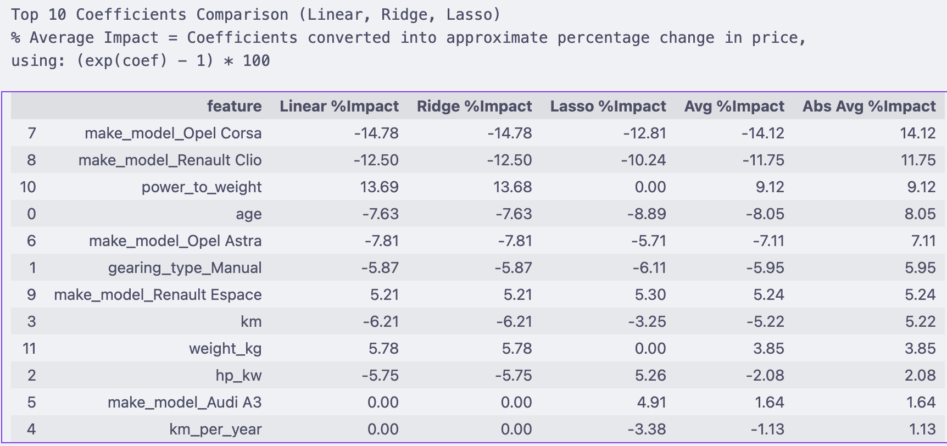

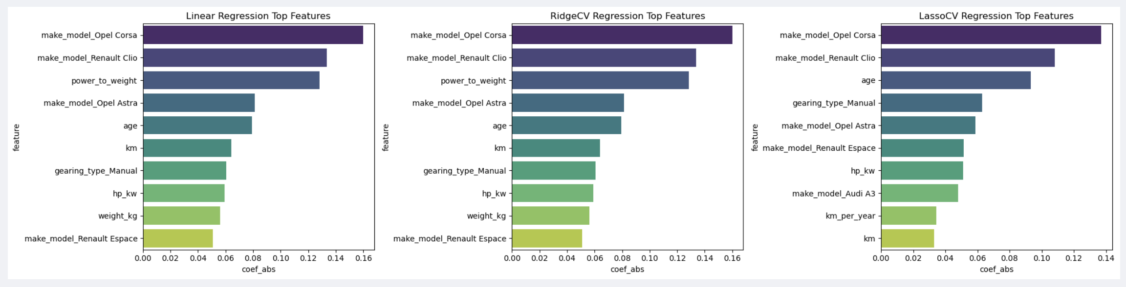

Bottom 10 Coefficients Comparison (Linear, Ridge, Lasso)

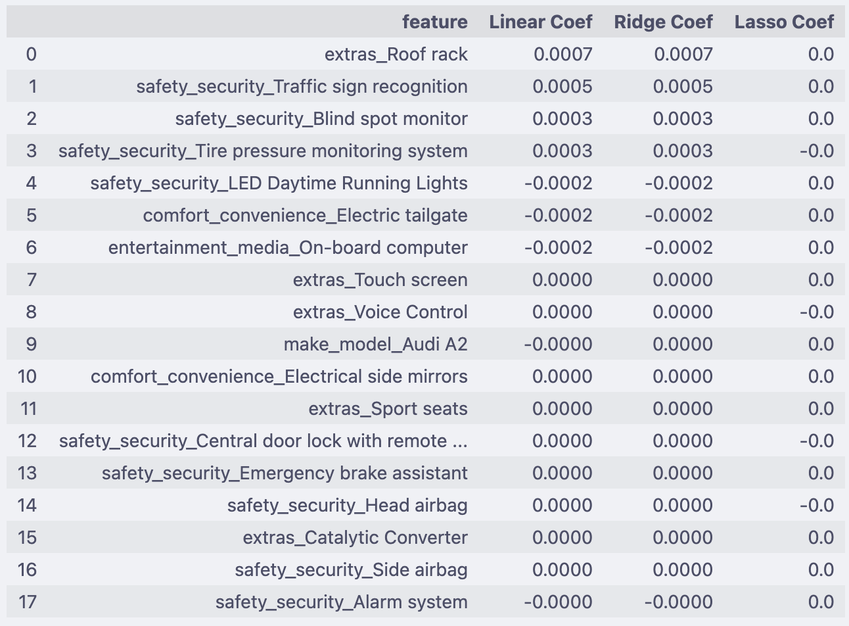

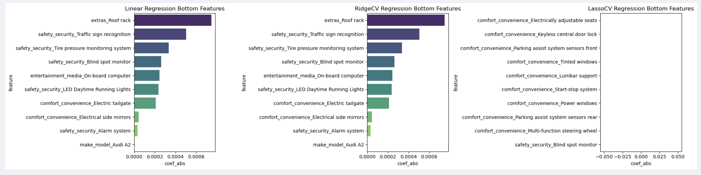

Lasso Model – Top 10, Bottom 10, and Dropped Coefficients (Side-by-Side)

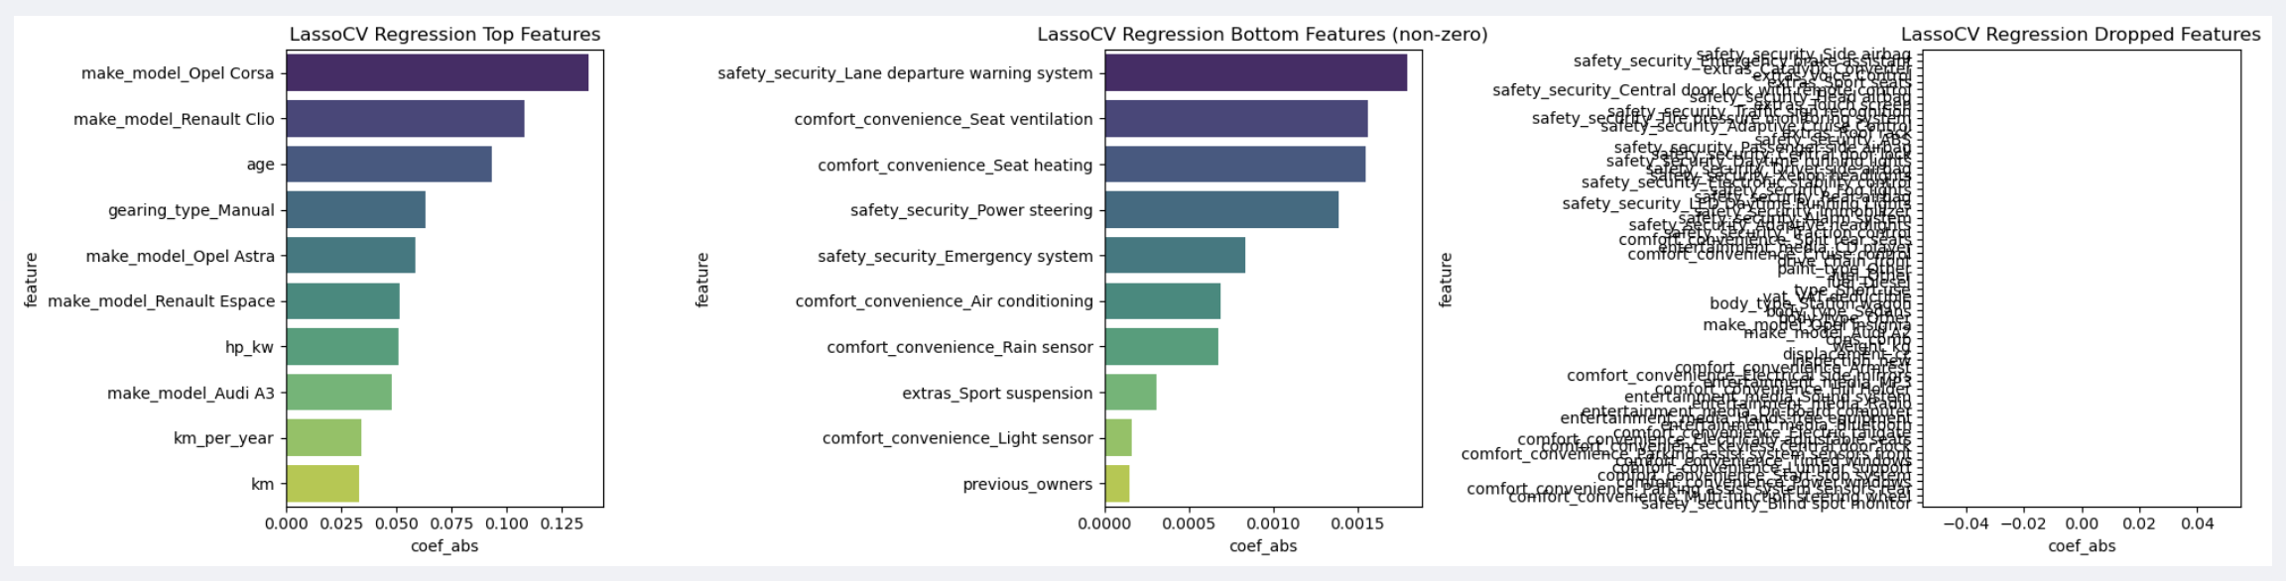

# Conclusion

## Model Performance Comparison Conclusion

|  |  |  |  |  |  |  |
| --- | --- | --- | --- | --- | --- | --- |
| Model | Alpha | RMSE | MSE | MAE | MAPE | R² |
| Linear | – | 1907.03 | 3.6368e+06 | 1221.70 | 0.0706 | 0.9061 |
| RidgeCV | 0.01 | 1907.03 | 3.6368e+06 | 1221.70 | 0.0706 | 0.9061 |
| LassoCV | 0.005 | 2056.93 | 4.2309e+06 | 1301.57 | 0.0751 | 0.8908 |

### Observations

* **Overall**:
  + All three models perform very closely, with Linear and Ridge being nearly identical in predictive accuracy:
  + RMSE ≈ 1907, MAE ≈ 1222, R2 ≈ 0.906.
  + LassoCV performs slightly lower in accuracy but gains interpretability by pruning irrelevant features.
  + 🡪 Predictive accuracy is effectively the same, with R2 ≈ between 0.89 and 0.91 for all models.
* **Baseline Linear Regression**
  + Already strong: R² ≈ 0.906, MAE ≈ 1222.
  + Regularization adds little to predictive accuracy but helps with stability and interpretability when features are correlated.
* **RidgeCV**
  + Chosen **α = 0.01**
  + Metrics nearly identical to baseline linear regression.
  + Regularization doesn’t change predictions much but:
  + Stabilizes coefficients.
  + Slightly reduces overfitting and multicollinearity risk.
  + Best suited when you want to **retain all features** but make them **less sensitive to correlation**.
* **LassoCV**
  + Chosen **α = 0.005**
  + Predictive performance slightly lower (R² drops from **0.906 → 0.891**) but:
  + Performs **automatic feature selection** — dropped **64 of 104 features**.
  + Model becomes leaner, easier to interpret, and computationally efficient.
  + Excellent choice when **simplification and interpretability** are priorities.

### Model Behaviour Summary

|  |  |  |  |
| --- | --- | --- | --- |
| Aspect | Linear | Ridge | Lasso |
| Regularization Strength | None | Weak (α = 0.01) | Weak (α = 0.005) |
| Feature Shrinkage | No | Mild | Strong |
| Feature Elimination | No | No | Yes |
| Multicollinearity Control | No | Yes | Yes |
| Interpretability | Moderate | Moderate | High |
| Predictive Accuracy (R²) | 0.906 | 0.906 | 0.891 |

### Model Performance Comparison Summary

* **Predictive power**: All three models are essentially equivalent in performance (differences are in the 3rd decimal place).
* **RidgeCV**: Best if your goal is to handle multicollinearity and keep all features with shrunk coefficients.
* **LassoCV**: Best if you want to simplify the model by feature selection (dropping irrelevant predictors).
* **Baseline Linear Regression**: Already very good; regularization doesn’t add predictive accuracy but can help with coefficient stability (Ridge) or sparsity (Lasso).

### Predictors and Coefficients Comparison

#### Top Predictors across Models

|  |  |  |  |  |
| --- | --- | --- | --- | --- |
| Feature | Linear Coef | Ridge Coef | Lasso Coef | Interpretation |
| make_model_Opel Corsa | -0.1599 | -0.1599 | -0.1370 | Budget model → strong negative impact. |
| make_model_Renault Clio | -0.1336 | -0.1336 | -0.1081 | Negative impact — entry-level, lower resale. |
| power_to_weight | 0.1283 | 0.1283 | 0.0000 | Performance proxy — strong in Linear/Ridge, dropped in Lasso (redundant with hp). |
| age | -0.0794 | -0.0794 | -0.0931 | Older cars lose value; consistent across models. |
| make_model_Opel Astra | -0.0813 | -0.0813 | -0.0588 | Moderate negative impact. |
| gearing_type_Manual | -0.0605 | -0.0605 | -0.0630 | Manual cars valued lower. |
| km | -0.0641 | -0.0641 | -0.0330 | More mileage → lower resale. |
| make_model_Renault Espace | 0.0508 | 0.0508 | 0.0516 | Family model → mild positive value. |
| weight_kg | 0.0562 | 0.0562 | 0.0000 | Dropped by Lasso (collinear with hp_kw). |
| hp_kw | -0.0593 | -0.0592 | 0.0513 | Power drives price, but interaction effects differ. |

### Bottom Predictors across Models

|  |  |  |  |  |
| --- | --- | --- | --- | --- |
| Feature | Linear Coef | Ridge Coef | Lasso Coef | Interpretation |
| extras_Roof rack | 0.0007 | 0.0007 | 0.0 | Insignificant accessory, no resale effect. |
| safety_security_Traffic sign recognition | 0.0005 | 0.0005 | 0.0 | Negligible premium. |
| safety_security_Blind spot monitor | 0.0003 | 0.0003 | 0.0 | No measurable impact. |
| safety_security_LED Daytime Running Lights | -0.0002 | -0.0002 | 0.0 | Cosmetic only, ignored by Lasso. |
| comfort_convenience_Electric tailgate | -0.0002 | -0.0002 | 0.0 | Minimal influence on price. |
| extras_Touch screen | 0.0000 | 0.0000 | 0.0 | Common feature, no price differentiation. |
| extras_Voice Control | 0.0000 | 0.0000 | -0.0 | Negligible or redundant. |
| make_model_Audi A2 | -0.0000 | 0.0000 | 0.0 | Irrelevant; dropped by Lasso. |
| safety_security_Central door lock... | 0.0000 | 0.0000 | -0.0 | Basic equipment, zero effect. |
| extras_Catalytic Converter | 0.0000 | 0.0000 | 0.0 | Standardized; zero importance. |

### Lasso Simplification

61% of the low impact features dropped by Lasso, simplifying the model interpretation. Examples of **Lasso Dropped Example Features:**

* extras_Voice Control
* comfort_convenience_Power windows
* safety_security_Blind spot monitor
* extras_Sport seats
* comfort_convenience_Start-stop system

These are redundant or low-impact features — Lasso confirms they don’t contribute meaningfully once stronger predictors (hp, age, mileage, brand/model) are included.

|  |  |
| --- | --- |
| Category | Count |
| Total features | 104 |
| Retained (non-zero) | 40 |
| Dropped (coeff = 0) | 64 |

#### Consistency in Top Drivers

Across all three models, the same top features dominate price prediction:

* **hp_kw, km, age, Opel/Renault model dummies, gear type, car type**
* Signs and magnitudes are stable (Ridge shrinks them slightly).

#### Regularization Impact

* **Ridge:** Shrinks extreme coefficients (Opel Corsa, Renault Clio, hp_kw) but keeps all features.
* **Lasso:** Drops weak/irrelevant features (e.g., Audi A2, cons_comb → coefficients forced to 0).

#### Bottom Features Behavior

* **Linear Regression:** Leaves tiny but noisy coefficients (e.g., cons_comb small but nonzero).
* **Ridge:** Shrinks these to small values but never to zero.
* **Lasso:** Removes them entirely → cleaner model, better interpretability.

#### Summary

* **If interpretability and feature selection matter → Lasso wins.**
* **If keeping all features while handling collinearity → Ridge is safer.**
* **If you just want predictive accuracy → even baseline Linear is already strong.**

#### Business Takeaway

* **Key Price Drivers Are Clear and Stable**
  + Engine power (**hp_kw**), mileage (**km**), car age, and certain premium/budget models (Opel/Renault/Audi dummies) consistently dominate price prediction across all models.
  + This confirms where pricing focus should be: **high-power, newer, low-mileage, premium models command higher prices**, while older, used, and manual vehicles depress resale value.
* **Regularization Supports Decision-Making**
  + **Ridge regression** stabilizes coefficients, reducing risks of overestimating correlated features like engine size and weight.
  + **Lasso regression** identifies irrelevant or redundant features (e.g., comfort convenience related) that do not meaningfully influence pricing, simplifying analysis and reporting.
* **Actionable Insight for Pricing Strategy**
  + Focus marketing and sales efforts on features that consistently boost value (premium models, high engine power, low mileage).
  + Avoid overcomplicating pricing models with low-impact features; Lasso highlights which features can be safely ignored.
  + Use Ridge when all features matter but multicollinearity exists, ensuring stable coefficient estimates for decision-making.
* **Predictive Accuracy vs Interpretability**
  + All three models (Linear, Ridge, Lasso) predict price with near-identical accuracy (R² ≈ 0.895-0.906).
  + **Decision-makers should choose model type based on business need:**
  + Simplified, interpretable pricing → **Lasso**
  + Robust estimates including all features → **Ridge**
  + Quick baseline insights → **Linear regression**